Oracle Linux 5 and 6 System Administration
Version: 5.1
Oracle 1z0-100 Exam
QUESTION NO: 1
Which two statements are true concerning the installation and configuration of the bootloader by the Anaconda installer, which is then used to boot Oracle Linux?
A. The Linux Loader (LILO) bootloader may be chosen for installation.
B. The bootloader must be password protected and Anaconda prompts for a password in all cases.
C. The Grand Unified Bootloader (GRUB) is the only bootloader used by Oracle Linux.
D. If previously installed operating systems are found on disk partitions that were not overwritten, then an attempt is made to configure the bootloader to be able to boot them.
E. The bootloader is installed by default in the first partition of the disk.
Answer: A,E
Explanation: A (not C): Linux boot process from hard drive: 1.
PC initializion phase - BIOS, POST.
2. PC starts boot loader - usually grub or lilo.
3. The bootloader locates kernel image on the hard drive.
4. The kernel decompresses and loads itself. Once finished it tries to mount the root filesystem.
5. When the root filesystem is mounted, /sbin/init is executed and continues booting the system using inittab and /etc/rc*.d scripts
QUESTION NO: 2
You want to display the value of a shell variable called service after assigning a value as shown:
SERVICE =ACCT S
Which two settings will display the name of the variable and its value?
A. set | grep service B. echo $SERVICE
C. env | grep SERVICE
D.env $SERVICE E.set $SERVICE
Answer: B,C
Explanation: C: env - set the environment for command invocation
If no utility operand is specified, the resulting environment shall be written to the standard output, with one name= value pair per line.

Oracle 1z0-100 Exam
QUESTION NO: 3
Which statements is true concerning Oracle Linux configuration files for users and groups?
A. The /etc/passwd file contains hashed passwords for each user.
B. The /etc/shadow file contains hashed passwords for each user.
C. The GECOS field in /etc/passwd file may be empty.
D. The /etc/group file contains the group name and the hashed group password.
Answer: B
Explanation: /etc/shadow file stores actual password in encrypted (one-way hashed) format for user's account with additional properties related to user password i.e. it stores secure user account information
QUESTION NO: 4
Examine these statements and their output taken right after successful install of Oracle Linux:
[root@FAROUT /] rpm -q firstboot
Firstboot -1.110.10-1.0.2.e16.x86_64
[root @FAROUT /] # chkconfig - - list firstboot
Firstboot 0:off 2:off 3:off 4:off 5:off 6;off
[root@FAROUT /] # /etc/sysconfig/firstboot
RUN_FIRSTBOOT=NO
What is the conclusion?
A. The option to run firstboot was deselected during Oracle Linux installation.
B.The system was installed with desktop graphical packages and rebooted and the firstboot utility ran successful.
C.Firstboot never ran in any run level because the service is turned off for all run levels.
D.The system was installed without selecting desktop graphical packages, thereby disabling firstboot from running.

Oracle 1z0-100 Exam
Answer: A
Explanation: Firstboot is set to off for all levels.
Example:
The rm command below remove or delate the firstboot file in order to make sure the firstboot program running when we restart or reboot the Fedora machine.
[root@fedora ~]# rm /etc/sysconfig/firstboot
rm: remove regular file `/etc/sysconfig/firstboot'? y [root@fedora ~]#
Then check and make sure that firstboot program or firstboot service is run when your Fedora startup/boot up.
Check firstboot services
[root@fedora ~]# chkconfig --list firstboot firstboot 0:off 1:off 2:off 3:off 4:off 5:off 6:off [root@fedora ~]#
QUESTION NO: 5
Which three settings can be controlled by using the chage breemar command as the root user, to modify the parameters in the /etc/shadow file?
A.The expiration date of the breemar account
B.The number of days after the breemar account is locked, that it becomes expired
C.The maximum number of days that must elapse between password changes by the user breemar before the password becomes invalid
D.The number of days after the breemar account is locked, that it becomes unlocked
E.The minimum number of days that must elapse between password changes by the user breemar
F.The maximum number of failed login attempts on the breemar account before the account is locked
Answer: A,C,E
Explanation: A: chage -E, --expiredate EXPIRE_DATE
Set the date or number of days since January 1, 1970 on which the user's account will no longer be accessible.
CE: You need to use chage command to setup password aging.
The chage command changes the number of days between password changes

Oracle 1z0-100 Exam
and the date of the last password change. This information is used by the system to determine when a user must change his/her password.
QUESTION NO: 6
Examine this extract from the /etc/ssh/sshd_config file:
passwordAuthentication no
What is the effect of this parameter settings on the use of openSSH commands on both the client and server?
A.Passwords are not required and no ssh-keygen is required either. Only passphrase are required.
B. Client users whose keys are not in the authorized_keys file on the server are unable to use passwords to authenticate themselves to the server.
C.The ssh daemon does not ask for a password before starting or stopping the sshd service.
D.Client users whose keys are not in the authorized_keys file on the client are unable to use passwords to authenticate themselves to the server.
Answer: B
Explanation: If you set PasswordAuthentication to no, you will no longer be able to use a login and password to authenticate and must use a login and public key instead (if PubkeyAuthentication is set to yes).
QUESTION NO: 7
Which four statements are true about software on the Oracle Public YUM server?
A. It contains Oracle Linux installation ISO images.
B. It contains Oracle Linux binary RPM packages.
C. It contains Oracle Linux errata packages.
D. It contains Oracle Linux source RPM packages.
E. It contains beta Oracle Linux software packages.
F. It does not contain Unbreakable Enterprise Kernel packages.
Answer: B,C,D,F
Explanation: The Oracle public yum server offers a free and convenient way to install the latest

Oracle Linux packages as well as packages from the Oracle VM installation media via a yum client.
Oracle provides all errata and updates for Oracle Linux via the Public Yum service, which includes updates to the base distribution, but does not include Oracle-specific software.
F: By default, all new installations of Oracle Linux 6 Update 5 are automatically configured to use the public yum update service. If you subsequently register the system with ULN, the public yum service is automatically disabled.
QUESTION NO: 8
This MDADM output:
Which two aspects can be determined from this output?
A. A device failed and has been removed from this RAID set.
"Pass Any Exam. Any Time." - www.TWPASS.com | 6

Oracle 1z0-100 Exam
B.It is no longer possible to write to this RAID set.
C.Read and write performance is no longer optimal on this RAID set. D.This RAID set was built without a spare device.
E.Only Write performance is no longer optimal on this RAID set.
Answer: A,D
Explanation:
QUESTION NO: 9
Examine the command on its output:
[root@FAROUT ~] # modprobe -v nfs
Insmod /lib/modules/2.6.39-100.0.12.e16uek.x86_64/kernel/fs/nfs_common/nfs_acl.ko insmod /lob/modules/2.6.39-
100.0.12.e16uek.x86_64/kernel/net/sunrpc/auth_gss/auth_rpcgss.ko
Insmod /lib/modules/2.6.39-100.0.12.e16uek.x86_64/kernel/fs/fscache/fscache/ko
Insmod /lib/modules/2.6.39-100.0.12.e16uek.x86_64/kernel/fs/locked.ko
Insmod /lib/modules/2.6.39-100.0.12.e16uek.x86_64/kernel/fs/nfs/nfs.ko
Which two statements are true about the modprobe command?
A.It will load the nfs module if all the modules upon which it depends have been loaded.
B.It displays the dependency resolution for the nfs module and loads all the modules upon which nfs depends before loading the nfs module.
C.It verifies that the nfs module and all other modules that depend on the nfs module are installed.
D.It displays the dependency resolution that would occur if the nfs module were to be loaded using modprobe nfs.
E.It only loads the nfs module if all the modules upon which it depends have not been loaded yet.
Answer: A,B
Reference: http://redhat.activeventure.com/8/customizationguide/ch-kernel-modules.html (kernel module utilities)
"Pass Any Exam. Any Time." - www.TWPASS.com | 7
Oracle 1z0-100 Exam
QUESTION NO: 10
What is the main advantage of the Oracle Unbreakable Enterprise Kernel compared with the Red Hat compatible kernel?
A. It is more secure and, therefore, more difficult to hack. B. It has a lower Mean Time Between Failures.
C. It provides higher availability for applications by reducing Mean Time to Recovery. D.It scales better for more CPUS, memory, and Infiniband network connections.
Answer: D
Explanation: The Unbreakable Enterprise Kernel, for those who want to leverage the latest features from
mainline Linux and boost performance and scalability.
The Red Hat Compatible Kernel, for those who prefer strict Red Hat kernel ABI (kABI) compatibility.
QUESTION NO: 11
Examine this output:
# df -t nfs
FilesystemSizeUsedAvailUse%Mounted on
o16:export30G21G7.6G74%/mnt
# 1s -1 /mnt/nfs.sh
-rwxr-mr-x. 1 root root 22 May 8 16:37 /mnt/nfs.sh
# file /mnt/nfs.sh
/mnt/nfs.sh: Bourne-Again shell script text executables
# /mnt/nfs.sh
bash: /mnt/nfs.sh: Permission denied
"Pass Any Exam. Any Time." - www.TWPASS.com | 8
Oracle 1z0-100 Exam
What is the reason for the error?
A.The file system was exported on host o16 using the ROOT_SQUASH option.
B.The /export filesystem was mounted with the NOEXEC option on host o16. C.The filesystem mounted on /mnt was mounted with the NOEXEC option.
D.The filesystem was exported on host o16 by using the NO_ROOT_SQUASH option.
Answer: C
Explanation:
QUESTION NO: 12
Which two software packages are prerequisites for enabling the configuration and use of a Network information Service (Nis) client?
A. nis-tools B.slapi- nis
C. ypbind D.nisserv E. nisbind F. yp-tools
Answer: C,F
Explanation: ypbind finds the server for NIS domains and maintains the NIS binding information. The client (normaly the NIS routines in the standard C library) could get the information over RPC from ypbind or read the binding files.
QUESTION NO: 13
You recently updated the strace package to the latest version as shown:
"Pass Any Exam. Any Time." - www.TWPASS.com | 9
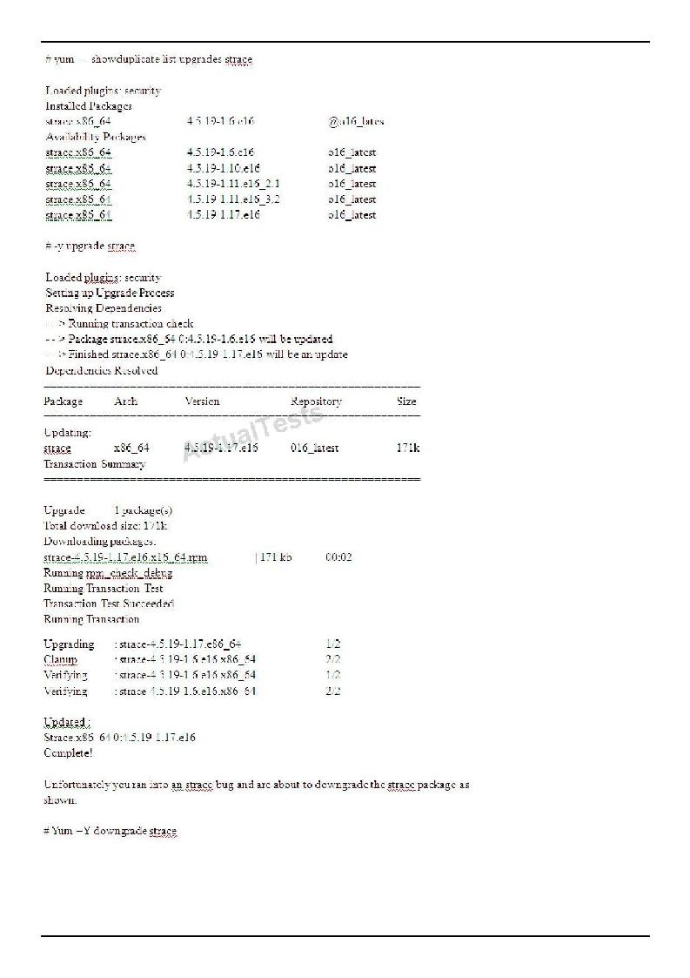
Oracle 1z0-100 Exam
What is the outcome of running this command?
"Pass Any Exam. Any Time." - www.TWPASS.com | 10
Oracle 1z0-100 Exam
A.It downgrades the strace package to version 4.5.19-1.6.e16.
B.It downgrades strace package to version 4.5.19-1.11.e16_3.2.
C.It fails with an error because you cannot downgrade a package using the yum command.
D.It fails with an error because there are multiple versions available to which Yum can downgrade the strace package.
E.It will prompt you to select a version of the strace package that you want to downgrade.
Answer: A
Explanation:
QUESTION NO: 14
Which two Statements are true concerning the configuration and use of cron and anacron?
A.Anacron jobs are used to make sure cron jobs run if the system had been down when they were meant to run.
B.All crontabs are held in the /etc/cron.d directory. C.
Cron jobs may run as frequently as once a minute.
D. Anacron jobs may run as frequently as once a minute. E.
The crond daemon looks for jobs only in /etc/crontab.
Answer: A,C
Explanation:
QUESTION NO: 15
Which statement is true concerning the /etc/sysconfig directory and its files and subdirectories?
A.The contents are always the same for a specific version of the Oracle Linux Kernel.
B.The file /etc/sysconfig/init is used by upstart to control the attributes of the tty devices that get started.
C.The directory /etc/sysconfig/network-scripts contains files that must not be modified while the network is up.
D.The files only contain default values for certain daemon processes.
Answer: B
Explanation: The /etc/sysconfig/init file controls how the system appears and functions during the boot process.
Note: The /etc/sysconfig directory contains files that control your system's configuration. The contents of this directory depend on the packages that you have installed on your system
"Pass Any Exam. Any Time." - www.TWPASS.com | 11
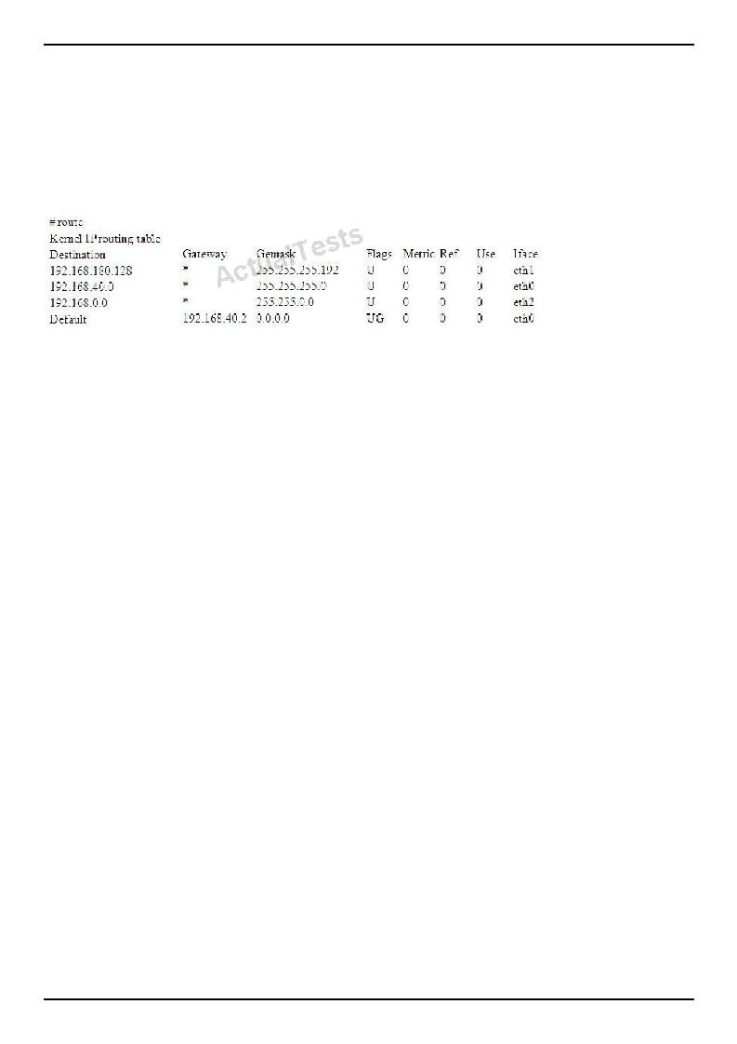
Oracle 1z0-100 Exam
QUESTION NO: 16
Examine the routing table:
Which three statements are true concerning the routing of IP packets?
A. Traffic to 192.168.180.180 is routed via eth1. B.
Traffic to 192.168.180.240 is routed via eth1. C.
Traffic to 192.168.0.42 is routed via eth2.
D. Traffic to 192.168.42.42 is routed via eth2. E.
Traffic to 192.168.42.42 is routed via eth0.
F. Traffic to 192.168.180.180 is routed via eth0.
Answer: A,C,D
Explanation:
QUESTION NO: 17
You have a single network adapter called eth0.
DEVICE = eth0
BOOTPROTO=DHCP
HWADR=BC:305B:C5:63;F1
NM_CONTROLLED=no
ONBOOT=YES
TYPE=Ethernet
PEERDNS=no
"Pass Any Exam. Any Time." - www.TWPASS.com | 12
Oracle 1z0-100 Exam
UUID=C9dba2e8-9faf-4b77-bbe2-92dd81dda1f9
Which two Statement:; are true concerning eth0 based on this configuration?
A.DHCP is used to obtain a lease on an IP address.
B.The dhclient command may only be used to obtain a lease at boot time. C.dhclient does not override the contents of /etc/resolv.conf. D. DNS is not used to resolve host names for this adapter. E. dhclient overrides the contents of /etc/resolv.conf.
Answer: A,C
Explanation: A: BOOTPROTO=DHCP
C: PEERDNS=answer
where answer is one of the following:
yes — Modify /etc/resolv.conf if the DNS directive is set. If using DHCP, then yes is the default. no — Do not modify /etc/resolv.conf.
Note: The "/etc/resolv.conf" file is used to configure the location of the DNS servers to be used for name resolution.
QUESTION NO: 18
Which four statements are true about the proc and sysfs filesystem?
A. The sysfs filesystem contains information about processes. B.
The proc filesystem contains information about CPUs.
C. The proc filesystem contains information about memory. D.
The sysfs filesystem contains information about CPUs.
E.The sysfs filesystem contains information about memory.
F.The proc filesystem contains information about the installer parameters.
Answer: B,C,D,F
Explanation: * sysfs is the Virtual Filesystem created during the 2.6 Kernel release cycle to show device information as procfs did not do this type of information that well.
Memory etc has not been ported to sysfs as it was never intended to show that type of information so it is unlikely it will be ported at all.
* sysfs is a virtual file system provided by Linux. Sysfs exports information about devices and drivers from the kernel device model to user space, and is also used for configuration.
"Pass Any Exam. Any Time." - www.TWPASS.com | 13
Oracle 1z0-100 Exam
QUESTION NO: 19
You want sendmail to deliver mail for these users:
John.smith@acme.comto mailbox jsmith1
John.smith@foo.comto mailbox jsmith2
John.smith@bar.comto mailbox jsmith3
In which sendmail configuration database can this requirement be defined?
A./etc/aliases
B./etc/mail/userdb
C./etc/mail/virtusertableD. /etc/mail/domaintable E. /etc/mail/genericstable
Answer: C
Explanation: /etc/mail/virtusertable
This database file maps mail addresses for virtual domains and users to real mailboxes. These mailboxes can be local, remote, aliases defined in /etc/mail/aliases, or files. This allows multiple virtual domains to be hosted on one machine.
The following example demonstrates how to create custom entries using that format:
root@example.com root
postmaster@example.com postmaster@noc.example.net @example.com joe
QUESTION NO: 20
What is the purpose of Setting AUTOINSTALL to YES /etc/uptrack.conf?
A.To install Ksplice kernel updates during the reboot of a system
B.To install updates to the Ksplice software Itself during a system reboot
C.To enable the uptrack cron job to install Ksplice kernel updates whenever they become available
"Pass Any Exam. Any Time." - www.TWPASS.com | 14
Oracle 1z0-100 Exam
D.To enable Ksplice to automatically install the kernel rpm whenever new Ksplice kernel updates become available
E.To enable Ksplice to install Ksplice kernel updates and new kernel RPMS whenever they become available
Answer: D
Explanation: If you'd like Ksplice Uptrack to automatically install updates as they become available, run:
sh install-uptrack YOUR_ACCESS_KEY --autoinstall
in place of the above install-uptrack command, or set "autoinstall = yes" in your /etc/uptrack/uptrack.conf after installation.
Note: Automatic updates
You can configure your systems to automatically install updates as they become available. To enable autoinstall, set autoinstall = yes in your /etc/uptrack/uptrack.conf, or pass the --autoinstall flag during installation.
Autoinstall is our most popular configuration. It is a scalable way to ensure that updates get installed quickly as they become available, regardless of when they are released.
Please note that enabling autoinstall does not mean the Uptrack client itself is automatically upgraded. You will be notified via e-mail when a new Uptrack client is available, and it can be upgraded through your package manager.
QUESTION NO: 21
Which two conditions should be met in order to successfully configure an openssh client on Oracle Linux?
A. The openssh-server package must not be installed. B.The openssh package must be installed. C. The sshd daemon must not be started.
D. The openssh-client package must be installed. E.The ssh-agent must be started.
F. ssh keys must be generated by any user using the ssh client.
Answer: B,D
Explanation: To connect to an OpenSSH server from a client machine, you must have the openssh-clients and openssh packages installed on the client machine.
"Pass Any Exam. Any Time." - www.TWPASS.com | 15
Oracle 1z0-100 Exam
QUESTION NO: 22
Which three settings are required to configure an openLdap to use directory service provided by Ldap.example.com?
A.Set the LDAP Search Base DN and the LDAP server address and post in /etc/openldap/ldap.conf to:
dc=example, dc = com ldap://ldap.example.com:389
B.Set LDAP Search Base DN and the LDAP server address and port in /etc/ldap.conf to: dc=example, dc=com
ldap://ldap.example.com:389
C.Ensure that /etc/nsswitch.conf correctly references authentication priorities:
passed: files ldap shadow: files ldap
group: files ldap
D.Ensure that the LDAP server name can be resolved.
E.Ensure that DNS is used to resolve the LDAP server name.
Answer: A,C,E
Explanation: A: The configuration file for the OpenLDAP libraries is /usr/local/etc/openldap/ldap.conf.
C: In order to use LDAP naming services, you must also properly configure all LDAP client machines, in addition to modifying the nsswitch.conf
E: The client's domain name must be served by the LDAP server
QUESTION NO: 23
Refer to the Exhibit.
[root@server1 ~ # 1s -1 /usr/bin/passwd
-r-x—x—x 1 root root 21200 oct 7 21:01 /usr/bin/passwd
[root@server1 ~] # 1s -1 /etc/shadow
-r - - - - - - - - 1 root root 1818 Mar 7 10:31 /etc/shadow]
[root@server1 ~]#
"Pass Any Exam. Any Time." - www.TWPASS.com | 16
Oracle 1z0-100 Exam
A user smith is on your system complained that he is not able to change his password. As the administrator, you long-listed the passwd command and the /etc/shadow file.
View the Exhibit that shows the output.
What must you do to enable this user to change his password?
A. Set SGID on /usr/bin/passwd. B. Set
SUID on /usr/bin/passwd.
C.Set sticky bit on /usr/bin/passwd.
D.Set read and write permission for others on /etc/shadow. E.Set permission on /etc/shadow to 600.
Answer: B
Explanation:
QUESTION NO: 24
What happens if you reboot a Ksplice Uptrack-enabled system when the following conditions exist?
1.The Internet is unreachable due to a failing router.
2.The INSTALL_ON_REBOOT property is set to YES in /etc/uptrack/uptrack.conf.
A.The Ksplice updates are applied early in the boot sequence despite the fact that the Internet is unreachable.
B.The Ksplice updates are not applied during the boot sequence, but they will be applied as soon as the Internet becomes reachable again.
C.The updates are not applied during the boot sequence and will not be applied after the Internet has become reachable again.
D.The system waits in the boot sequence for the internet to become reachable again. E.
The system boots to single-user mode.
Answer: A
Explanation: * # Automatically install updates at boot time. If this is set, on
# reboot into the same kernel, Uptrack will re-install the same set of # updates that were present before the reboot.
install_on_reboot = yes
* To install updates automatically at boot time, the following entry must appear in
"Pass Any Exam. Any Time." - www.TWPASS.com | 17
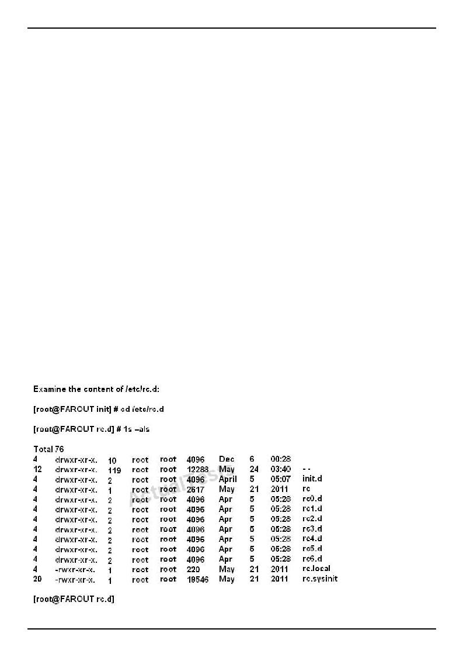
Oracle 1z0-100 Exam
/etc/uptrack/uptrack.conf:
install_on_reboot = yes
QUESTION NO: 25
Which two statements are true about administering the use of the Sudo command in Oracle Linux?
A.visudo will never save the /etc/sudoers file if there are syntax errors in the file after editing.
B.visudo prompts for an action if there are syntax errors in the /etc/sudoers file after editing. C.Using vi to edit /etc/sudoers opens the file read only.
D.Multiple administrators may edit the /etc/sudoers file simultaneously using visudo but only one may save the edited result.
E.Multiple administrators may edit the /etc/sudoers file simultaneously using vi but only one may save the edited result.
Answer: B,C
Explanation:
QUESTION NO: 26
"Pass Any Exam. Any Time." - www.TWPASS.com | 18
Oracle 1z0-100 Exam
Which four statements are about the use of these files and directories by UPSTART?
A./etc/rc.d/rc is executed each time the /sbin/init command us used, to change services appropriately for the target run level.
B./etc/rc.d/rc.local is executed at boot time, before the run level processing takes place.
C./etc/rc.d/rc is executed at boot time, to start the appropriate services for the run level defined in /etc/initab.
D./etc/rc.d/rc.sysinit is executed once at boot time, regardless of which run level is set.
E./etc/rc.d/rc.sysint is executed each time the /sbin/init command is used to change the run level.
F./etc/rc.d/rc3.d contains links to scripts in /etc/init.d. G. /etc/rc.d/rc is executed after /etc/rc.d/rc.local.
Answer: A,C,D,F
Explanation:
QUESTION NO: 27
Examine these details from the sysctl.conf file and from the proc file system:
[root@FAROUT fs]# grep aio-max-nr /etc/sysctl.conf
# oracle-rdbms-server-11gR2-preinstall setting for fs.aio-mx-nr is 1048576 fs.aio-max-nr = 1048576
[root@FAROUT fs] # cat /proc/sys/fs/aio-max-nr 1048576
[root@FAROUT fs] # rpm -q libaio Libaio-0.0.107-10.e16.x86_64Libaio-0.3.107-10.e76.i686
Which statement is true about the setting created by oracle-rdbms-server-11gR2-preinstall?
A.It allows a process to request an I/O without waiting for reply.
B.It allows two or more processes to request I/O simultaneously while running on different CPUs.
C.It allows a process to request a single I/O without awaiting for a reply. However, if a second I/O is requested, then the process must wait.
D.It allows two or more processes to request I/Os and then to both be notified when both of them complete.
"Pass Any Exam. Any Time." - www.TWPASS.com | 19
Oracle 1z0-100 Exam
Answer: B
Explanation:
QUESTION NO: 28
You use the chkconfig command to administer one of the services on your Oracle Linux system:
[root@FAROUT ~]# chkconfig vncserver off [root@FAROUT ~] #
No changes have been made to the init script for the service.
Which two statements are true regarding the effects of Issuing this command?
A.The vncserver service is shut down.
B.The vncserver service configuration is disabled only for those run levels for which it is currently enabled.
C.The vncserver service configuration is disabled for run levels 2, 3, 4 and 5.
D.The vncserver service remains in the same state it was in before the command was issued.
E.The vncserver service configuration is disabled for run levels 3 and 5 only.
Answer: C,D
Reference: http://www.oracle-base.com/articles/linux/configuring-vnc-server-on-linux.php
QUESTION NO: 29
Examine the commands used by root to create the chrooted environments in the /jail directory:
# mkdir /jail/bin/jail/lib64
# cp /bin/bash/jail/bin
linux-vdso.so.1 => (0x00007fff68dff000)
libtinfo.so.5 => /lib64/libtinfo.so.5 (0x00000033e00000)
lid1.so.2 => /lib64/libc.so.6 (0x00000033e1600000)
/lib64/id-linix-86-64.so.2 (0x00000033e0e00000)
"Pass Any Exam. Any Time." - www.TWPASS.com | 20
Oracle 1z0-100 Exam
#cp /lib64/libtinfo.so.5/jail/lib64
#cp /lib64/libd1.so.6 /jail/lib64
#cp /lib64/libc.so.6 /jail/lib64
#cp /lib64/id-linux-x86-64.so.2 /jail/lib64
The user root then issues this command:
# chroot /jail
What is the output from the cd, pwd, and 1s commands?
A.bash-4.1# cd bash- 4.1# pwd
/root bash-4.1# 1s
bash" 1s: command not found
B.bash-4.1# cd
bash: cd: /root: No such file or directory bash-4.1# pwd
/
bash-4.1 # 1s
bash: 1s: command not found C. bash-4.1# cd
bash: cd: command not found bash: pwd: command not found bash-4.1# 1s
D. bash: 1s; # cd
bash: cd: /root: unable to access chrooted file or directory /root bash-4.1# pwd
/
bash-4.1 # 1s bin lib64
E. bash-4.1# cd
bash: cd: /root: No such file or directory bash-4.1# pwd
/
bash-4.1# 1s bin lib64
Answer: B
Explanation:
"Pass Any Exam. Any Time." - www.TWPASS.com | 21
Oracle 1z0-100 Exam
QUESTION NO: 30
Examine the partition table:
Disk /dev/sdd: 107 MB
Sector size (logical/physical): 512B/512B
Partition Table: msdos
Number StartEndSizeTypeFileSystemFlags
11049KB79.7MB78.6MBPrimary
Which program cannot be used to add another partition on this device?
A.fdisk
B.cfdisk C. parted
D.kpartx
Answer: D
Explanation: kpartx - Create device maps from partition tables
Incorrect:
Not A: fdisk (in the first form of invocation) is a menu driven program for creation and manipulation of partition tables.
Not B: cfdisk is a disk partition manipulation program, which allows you to create, destroy, resize, move and copy partitions on a hard drive
not C: parted
GNU Parted - a partition manipulation program
QUESTION NO: 31
What is the purpose of setting ONPARENT = no in an Interface configuration file located in /etc/sysconfig/network-scripts?
A.To prevent a network interface from being brought up during system startup
B.To prevent a slave network interface from being brought up during system startup
"Pass Any Exam. Any Time." - www.TWPASS.com | 22
Oracle 1z0-100 Exam
C.To prevent an alias network interface from being brought up during system startup
D.To prevent a master network interface from being brought up during system startup
Answer: C
Explanation: The ONBOOT directive tells the network initialization scripts not to start a given interface.
If you need to stop a virtual interface from starting when the network interfaces are initialized, you need to set ONPARENT instead of ONBOOT to no.
Reference: Keep IP Aliases from Starting at Boot
QUESTION NO: 32
You must remove the user harhest from your Oracle Linux system because the person has left the company:
User harhest has numerous files, directories, and a crontab.
You issue:
Userdel -r harhest
Which three outcomes result from the execution of this command?
A. Files in the harhest home directory are removed. B.The home directory of harhest is removed.
C. Files owned by narhest in any directory are removed. D.All directories owned by harhest are removed.
E. The /var/spool/mail/harhest mailbox is removed. F.crontab /var/spool/cron/harhest is removed.
Answer: A,B,E
Explanation: The userdel command modifies the system account files, deleting all entries that refer to the user name LOGIN. The named user must exist.
parameter -r-r, --remove
Files in the user's home directory will be removed along with the home directory itself and the user's mail spool. Files located in other file systems will have to be searched for and deleted
"Pass Any Exam. Any Time." - www.TWPASS.com | 23
Oracle 1z0-100 Exam
manually.
QUESTION NO: 33
Match the rpm options with their functions:
--I a. replaces any older versions of package with the new package
--Ub. upgrades packages, but only if an earlier version exists on your system
--Fc. Uninstall the specified package
--ed. installs a new package
A. 1-d, 2-a, 3-b, 4-c B. 1-d,2-b, 3-a, 4-c C. 1-a, 2-c, 3-b,4-d D. 1-a, 2-b, 3-c, 4-d
Answer: A Explanation:F | Freshen
This will upgrade packages, but only ones for which an earlier : Which means 3 should be b
i
Installs new package U
upgrades or installs the package : Which means 2 should be ae
removes
QUESTION NO: 34
Examine the line from /etc/rsyslog.conf:
Mail.*-/var/log/maillog
Which statement correctly describes this rule?
A.The rule name prefix of "-" is tolerated for syslog and syslog.sys compatibility with no impact or rsyslog behavior regardless of the global directive settings.
B.The file name prefix of "-" is a way of disabling mail log messages under certain conditions to
"Pass Any Exam. Any Time." - www.TWPASS.com | 24
Oracle 1z0-100 Exam
/var/log/maillog.
C.The filename prefix of "-" is a performance enhancement. It stops file syncing on every message. The log certain will be the same whether a minus prefix is used or not.
D.The file name prefix of "-" forces file syncing after every message is logged to ensure each message is written to disk force before attempting to write a subsequent message to the same file.
Answer: C
Explanation: You may prefix each entry with the minus ``'' sign to omit syncing the file after every logging. Note that you
might lose information if the system crashes right behind a write attempt. Nevertheless this might give you
back some performance, especially if you run programs that use logging in a very verbose manner.
QUESTION NO: 35
Which two statements are true concerning a GUID Partition Table (GPT)?
A.It supports named disk partitions.
B.It supports primary and extended partitions. C. It supports disks greater than two terabytes. D. It cannot be used on the system disk.
E.It supports only up to 16 partitions.
Answer: A,C
Explanation:
not B, not E: On GUID Partition Table (GPT) hard disks, you can configure up to 128 partitions and there is no concept of extended or logical partitions. Not D: You cannot boot from a GPT disk.
QUESTION NO: 36
Examine the extract of the /etc/nologin file and the /etc/pam.d/login file on server1:
[root@server1 ~] # cat /etc/nologin
bob
smith
"Pass Any Exam. Any Time." - www.TWPASS.com | 25
Oracle 1z0-100 Exam
[root@server1 ~] # cat /etc/pam.d/login
accountrequiredpam_nologin.so accountincludesystem-auth
Which statement is true about users?
A.Only the root user can log in to the system.
B.Only users root bob and smith would be unable to log in to the system.
C.All users, including the root user, would be permitted to log in to the system. D.All users, including the root user, would be unable to log in to the system.
Answer: A
Explanation: auth required pam_nologin.so — This is the final authentication step. It checks whether the /etc/nologin file exists. If it exists and the user is not root, authentication fails.
*The /etc/nologin file contains the message displayed to users attempting to log on to a machine in the process of being shutdown.
*the login program defines its service name as login and installs the /etc/pam.d/login PAM configuration file.
QUESTION NO: 37
Which two statements correctly describe the type of Information and the behavior of files in the proc filesystem on Oracle Linux 6?
A.It is not possible to write to any file in the proc filesystem.
B.The /proc/cmdline file contains the parameters passed to the kernel.
C.Each process has a directory named for the process number in the proc filesystem.
D.The proc filesystem contains the same hardware information that is contained in the sys filesystem for backward compatibility.
E.Each process thread has a directory named for the process thread number in the proc files/stem.
Answer: C,D
Explanation:
"Pass Any Exam. Any Time." - www.TWPASS.com | 26
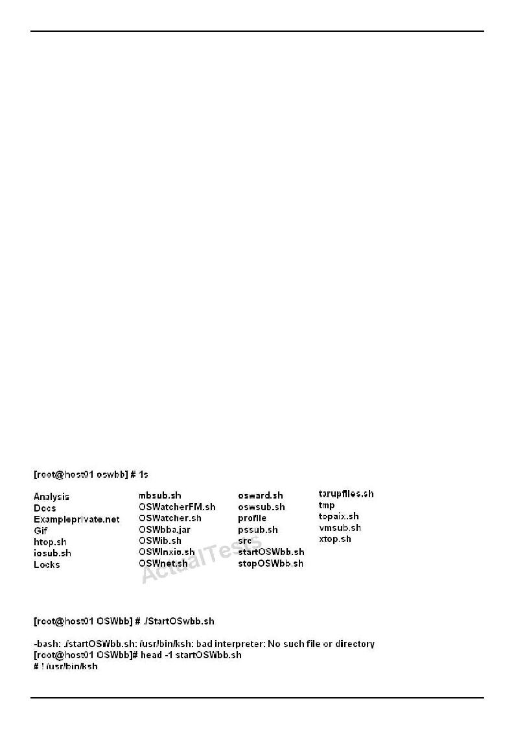
Oracle 1z0-100 Exam
QUESTION NO: 38
Which four statements are true concerning the various stages of GRUB bootloader in Oracle Linux?
A.GRUB stage1 must always load stage1_5.
B.GRUB stage1_5 is used to process the /boot/grub/grub.conf file. C.GRUB stage1_5 loads GRUB stage2.
D.GRUB stage1 may load GRUB stage2 directly.
E.GRUB stage1 provides support for several different filesystems, enabling stage1 to load stage1_5.
F.GRUB stage1_5 provides support for several different filesystems, enabling stage1_5 to load stage2.
G.GRUB stage2 is used to process the /boot/grub/grub.conf file.
Answer: C,D,E,G
Explanation: CD: Stage 1 code is stored in the MBR. This code contains a block list that points to the next stage of GRUB, which is either stage1_5 or stage 2, depending on the file system type. E(not F): Stage1_5 code allows GRUB to interpret different types of file system
G (not B): Stage 2 code reads /boot/grub/grub.conf to determine how to load the kernel. Incorrect:
Not A:. For some file system types such as ext4, GRUB does not need to load stage1_5.
QUESTION NO: 39
Examine the commands and output when trying to start OSWatcher Black Box.
"Pass Any Exam. Any Time." - www.TWPASS.com | 27
Oracle 1z0-100 Exam
Identify two recommended solutions to this problem.
A.Edit the startOSWbb.sh script to specify your proffered shell, ensuring that it is started in POSIX compliance mode.
B.Install ksh on the system, if not currently installed.
C.Create a Symbolic link /usr/bin/ksh that points to /bin/bash.
D.Ensure that ksh is accessible with the path /usr/bin/ksh. Create a symbolic link if necessary.
E.Create a shell alias called /usr/bin/ksh that expands to /bin/bash.
Answer: B,D
Explanation:
QUESTION NO: 40
Identify two true statements about the nice command.
A. It may the used to raise the priority of existing processes. B. It may be used to set the initial priority of a process.
C.A higher nice value makes a process run at a lower priority.
D.By default, a normal user can make a process run at a higher priority. E.It may be used to lower the priority of existing processes.
Answer: B,C
Explanation:
QUESTION NO: 41
Examine the output of a bonded interface configuration from which one network cable has been unplugged:
# cat /proc.net/bonding/bond0
Ethernet Channel Bonding Driver: v3.6.0 (September 26, 2009)
Bonding Mode: fault-tolerance (active-backup)
Primary Slave: None
Currently Active Slave: eth2
MII Status: up
MII poling interval (ms): 100
"Pass Any Exam. Any Time." - www.TWPASS.com | 28
Oracle 1z0-100 Exam
Up Delay (ms): 0
Down Delay (ms): 0
Slave Interface: eth1
MII status: down
Link Failure Count: 1
Permanent HW addr: 00:0c:29:7b:3c:71
Slave Queue ID: 0
Slave Interface: eth2
MII Status: up
Link Failure Count: 0
Permanent HW addr: 00:0c:29:7b:3s:7b
Which statement is true when you plug in the eth1 network cable?
A.The status of the slave interface eth1 changes to up and is promoted to the active slave and eth2 becomes the backup slave.
B.The status of the slave interface eth1 changes to up and becomes a second active slave.
C.The status of the slave interface eth1 changes to up but must be manually assigned the active or backup slave role.
D.The status of the slave interface eth1 changes to up and becomes the backup slave.
Answer: A
Explanation:
QUESTION NO: 42
Which three statements are true about the shared directories defined in the /etc/exports file?
A. By default, a directory is shared with no root squashed. B.By default, a directory is shared read write.
C. By default, a directory is shared with root squashed. D.By default, a directory is shared read only. E. By default, a directory is shared sync.
Answer: C,D,E
"Pass Any Exam. Any Time." - www.TWPASS.com | 29
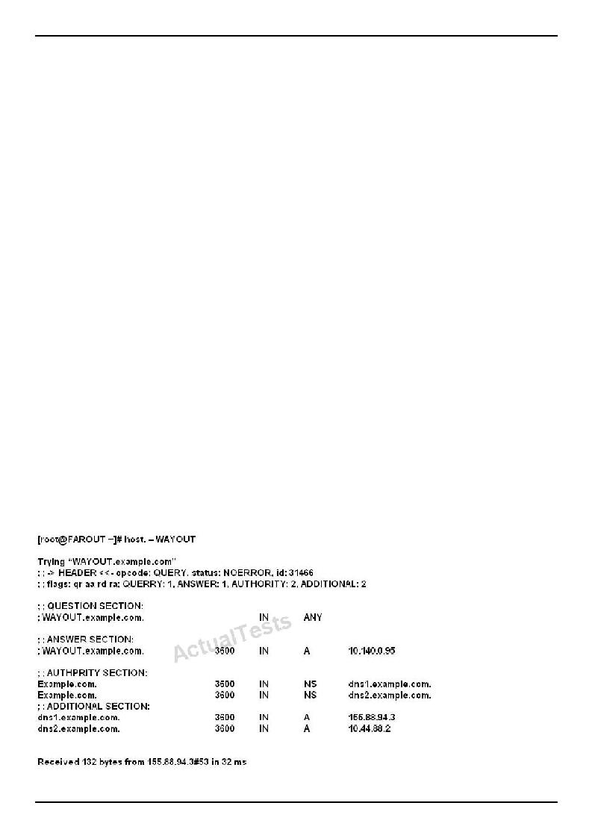
Oracle 1z0-100 Exam
Explanation: C (not A): Very often, it is not desirable that the root user on a client machine is also treated as root when accessing files on the NFS server. To this end, uid 0 is normally mapped to a different id: the so-called anonymous or nobody uid. This mode of operation (called 'root squashing') is the default, and can be turned off with no_root_squash.
E: In releases of nfs-utils up to and including 1.0.0, the async option was the default. In all releases after 1.0.0, sync is the default, and async must be explicitly requested if needed.
QUESTION NO: 43
Which three statements are true when using the Anaconda Installer to install Oracle Linux?
A.Unattended installation is only possible if installing the Unbreakable Enterprise kernel.
B.The installation may be done from an NFS-mounted Image.
C.Unattended installation is only possible if installing the Red Hat-compatible kernel. D.The installation may be done from a USB device.
E.The installation may be done in text or graphical mode.
Answer: B,D,E
Explanation:
QUESTION NO: 44
You use the host command to find out about host name WAYOUT:
"Pass Any Exam. Any Time." - www.TWPASS.com | 30
Oracle 1z0-100 Exam
Which two statements are true?
A.Example.com is an authoritative name server.
B.Dns1.example.com is an authoritative name server. C.Dns2.example.com is a Cache-only name server.
D.Dns2.example.com is an authoritative name sever. E.Dns1.example.com is a cache-only name server.
Answer: B,D
Explanation:
QUESTION NO: 45
Which three statements are true about the configuration of OpenLdap secure encrypted connections?
A.TLS and ldaps should not both be selected.
B.To enable idaps, you must download the Certifying Authority (CA) Certificate. C.To enable TLS, you must download the Certifying Authority (CA) Certificate.
D.The certificate is needed to verify ownership of the secret key used for encryption.
E.There is a command-line alternative to the Authentication Configuration Tool to enable the encrypted LDAP communication.
Answer: A,C,D
Explanation: Transport Layer Security (TLS) can be used to provide data integrity and confidentiality protection. OpenLDAP supports negotiation of TLS (SSL) via both StartTLS and ldaps://.
QUESTION NO: 46
Which two actions should be completed when the firstboot utility runs under runlevel 5 in Oracle Linux?
A.Agreeing to the license agreement
B.Registering for software updatedC. Creating a nonadministrative user
D.setting the current date and time to be synchronized with an NTP server
E.Configuring the dtrace facility
"Pass Any Exam. Any Time." - www.TWPASS.com | 31
Oracle 1z0-100 Exam
Answer: A,C
Explanation:
QUESTION NO: 47
Which two statements are true about the Unbreakable Linux Network (ULN)?
A.It is freely available to all Oracle Linux customers.
B.It contains additional packages not found on the installation media. C. It contains only binary RPM packages.
D.It contains both source and binary RPM packages. E. It is the only location to download errata.
F.All Unbreakable Linux subscribers are allowed to deploy a local YUM repository.
Answer: B,D
Explanation: B: ULN subscribers will find security updates and additional bugfixes for kernel and other packages. They will also be able to download useful extra packages not included in the original distribution.
D: You can also select to download the source RPM in addition to the binary RPMs.
Incorrect:
not A: How do I obtain a login for Unbreakable Linux Network (ULN)?
You may register for a ULN account via linux.oracle.com/register You will need the following:
An Oracle.com Single Sign on account. If you don't have one already, the link above will guide you through the steps to create one
A valid Oracle Linux support or Oracle VM support CSI (customer support identifier). You may purchase Oracle Linux or Oracle VM support online via the Oracle Linux Store or via your sales representative.
QUESTION NO: 48
Examine the content of the mdstat pseudo file:
# cat /proc/msstat
"Pass Any Exam. Any Time." - www.TWPASS.com | 32
Oracle 1z0-100 Exam personalities: [raid1] [raid0] [raid6] [raid5] [raid4]
md0 : active raid1 md2[1] md1[0]
207680blocks super 1.2 [2/2] [UU]
md2 : activeraid0 sdg[1] sdf1[0]
207872blocks super 1.2 512k chinks
Md1 :active raid0sde1[1] sdd1[0]
207872blocks super 1.2 512k chunks
Unused devices: <none>
Which two statements are true about the MD0 RAID set?
A.MDO is a stripped mirror RAID set.
B.MDO is a mirrored stripped RAID set. C.If MD1 fails, so will MDO.
D.If MD2 fails, MDO too fails.
E.If /dev/sdd1 and /dev/sdg1 fail, MDO fails.
Answer: B,E
Explanation:
QUESTION NO: 49
Examine these commands used to control UPSTART logging:
[root@FAROUT init] # initctl log-priority info
[root@FAROUT init] # initctl log-priority
Info
[root@FAROUT init]#
Which three statements are true about the logging done through these commands?
A. UPSTART logs State Changes to /vat/log/messages. B.
UPSTART logs job goals to /var/log/massages.
"Pass Any Exam. Any Time." - www.TWPASS.com | 33
Oracle 1z0-100 Exam
C.UPSTART logs only informational messages about warnings and errors to /var/log/messages.
D.UPSTART logs only informational messages about warnings to /var/log/messages. E.UPSTART logs event emissions to /var/log/messages.
Answer: A,C,E
Explanation:
QUESTION NO: 50
Which three statements are correct about NFSV4?
A. It relies on the LOCKD and RPC.STATD daemons to perform file locking. B.It uses a single port (2049) for all client/server communications.
C.The UID and GID for a particular user must be the same on both client and server to avoid file ownership problems.
D.It has support for filesystem quotas.
E.RPC.IDMAPD is used to map a UID to its username and a GID to its group name and vice versa.
Answer: C,D,E
Explanation: NFSv4 does not use rpcbind as the NFS server itself listens on TCP port 2049 for service
requests. The mounting and locking protocols are also integrated into the NFSv4 protocol, so the lockd and rpc.statd services are also not required. These refinements mean that firewall configuration for NFSv4 is no more difficult than for a service such as HTTP. https://docs.oracle.com/cd/E37670_01/E41138/html/ol_about_nfs.html
QUESTION NO: 51
Which three statements are true about rpm package dependencies?
A.The RPM command can detect only direct package dependencies.
B.The RPM command can detect both direct and indirect package dependencies.
C.The YUM command can detect and resolve direct and indirect package dependencies.
D.The YUM command can detect and resolve indirect package dependencies only within the same repository.
E.The YUM command can only detect and resolve direct package dependencies. F.
A source RPM can have a dependency on a binary RPM.
"Pass Any Exam. Any Time." - www.TWPASS.com | 34
Oracle 1z0-100 Exam
Answer: B,D,F
Explanation: D: yum deplist <package>
Produces a list of all dependencies and what packages provide those dependencies for the given packages.
QUESTION NO: 52
Examine the channel specification in the /etc/yum.repos.d/public-yum-016.repo file:
# head -6 /etc/yum.repos.d/public-yum-016.repo [016_latest]
Name=Oracle Linux $releasever Latest ($basearch)
Baseurl=http://public-yum.oracle.com/repo/oracleLinux/OL6/latest/$basearch/
Gpgkey=http://public-yum.oracle.com/RPM-CPG-KEY-oracle-o16
Gpgcheck=1
Enabled=0
What is the effect of the enabled=0 setting?
A.This channel is disabled and cannot be used by YUM at all.
B.This channel will not be used by YUM when searching for packages.
C.By default, YUM will not use this channel but this can be overridden on the command line.
D.This channel will not be used by YUM when it searches for packages, but YUM will check if updates exist for packages already installed from this channel.
Answer: B
Explanation: Disable YUM Repo (Repository)
Disable YUM Repo
Edit repo file on /etc/yum.repos.d/ as root and change enabled to 0
##Change enabled=1
##To enabled=0
"Pass Any Exam. Any Time." - www.TWPASS.com | 35
Oracle 1z0-100 Exam
QUESTION NO: 53
Which three statements correctly describes the purpose of and administration of kernel boot parameters in Oracle Linux?
A.Kernel boot parameters may be specified in /boot/grub/grub/conf.
B.Kernel boot parameters used to boot the running system may be examined after boot by Viewing /boot/grub/grub/conf.
C.Kernel boot parameters used to boot the running system may be examined after boot by viewing /proc/cmdline.
D.Additional kernel boot parameters may be specified in an administrator-specified parameter file that is read by grub stage.
E.Additional kernel boot parameters may be specified from the grub command line.
F.Additional kernel boot parameters may be specified in an administrator-specified parameters that is read by GRUB stage1_5.
Answer: A,C,E
Explanation:
QUESTION NO: 54
Which three options are available during the Anaconda installer disk partitioning setup stage for a machine with only one hard disk device?
A.Manual resizing of existing partitions on only a single device
B.Removal of all empty partitions only, leaving any Linux or non-Linux partitions unchanged
C.Replacing of existing Linux partitions only and leaving any other partitions unchanged
D.Replacing of existing non-Linux partitions only, and leaving any Linux partitions unchanged
E.Manual resizing of existing partitions on all selected devices
F.Removal of all existing partitions and creating new partitions to suit the install
Answer: A,C,F
Explanation: A: Shrink Current System
Select this option to resize your current data and partitions manually and install a default Red Hat Enterprise Linux layout in the space that is freed.
C: Replace Existing Linux System(s)
Select this option to remove only partitions created by a previous Linux installation. This does not remove other partitions you may have on your hard drives (such as VFAT or FAT32 partitions). F: Replace Existing Linux System(s)
Select this option to remove only partitions created by a previous Linux installation. This does not
"Pass Any Exam. Any Time." - www.TWPASS.com | 36
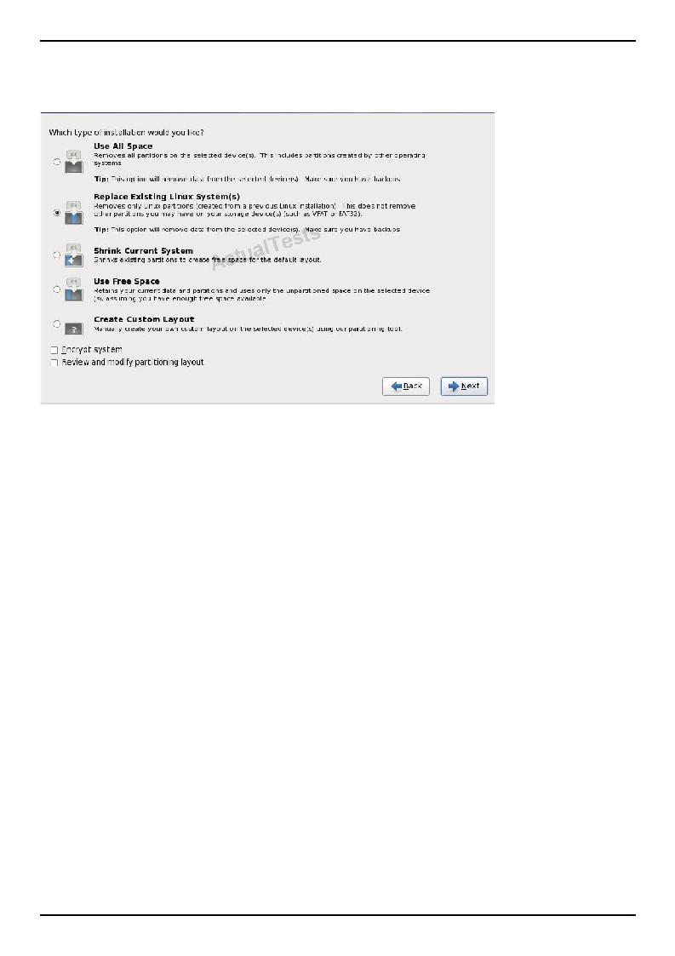
Oracle 1z0-100 Exam
remove other partitions you may have on your hard drives (such as VFAT or FAT32 partitions).
Note:
QUESTION NO: 55
Which two steps should be performed to permit using SSH, SCP, or SFTP commands by the ORACLE account on the host FAROUT to the oracle account on the host WAYOUT without supplying a password?
A.The oracle account user on host FAROUT must issue an ssh-keygen command to generate public and private key files in the ~ oracle/.ssh directory FAROUT.
B.The oracle account user on the host WAYOUT must issue an ssh-keygen command to generate public and private key files in the ~/oracle.ssh directory on WAYOUT.
C.The Oracle account user on host FAROUT must add the contents of ~/oracle/.ssh/id_dsa.pub or ~/oracle/.ssh/is_rsa.pub file to the ~/oracle/.ssh/authorized_keys file on host WAYOUT.
D.The Oracle account user on host WAYOUT must add the contents of ~/oracle/.ddh/id_dsa or ~/oracle/.ssh/id_rsa.pub file to the ~/oracle/.ssh/authorized_keys file on host FAROUT.
E.The oracle account user on host WAYOUT must set the permissions on the ~/oracle/.ssh/authorized_keys file to 644.
F.The Oracle account user on host FAROUT must set the permissions in
~/oracle/.ssh/authorized_keys file 644.
Answer: A,C
Explanation:
"Pass Any Exam. Any Time." - www.TWPASS.com | 37
Oracle 1z0-100 Exam
QUESTION NO: 56
Your Oracle Linux server has a network interface eth0 but the ifcfg-eth0 file is missing from the /etc/sysconfig/network-scripts directly.
To set the IP address for the interface, you run this command as root:
[root@station1]# ifconfig eth0 192.168.0.1 up
What is the effect of the command?
A.The IP address 192.168.0.1 is not assigned to eth0 because the netmask is not specified.
B.The IP address 192.168.0.1 is assigned to eth0, but the interface is not activated until the network service is reloaded.
C.The IP address 192.168.0.1 is assigned to eth0, but the interface is not activated until the network service is restarted.
D.The IP address 192.168.0.1 is assigned to echo with the default netmask for that address, and the interface is activated immediately.
Answer: D
Explanation:
QUESTION NO: 57
Examine this output:
$ ftp o16.example.com
Connected to o16.example.com (192.168.40.131) 220 (vsFTpd 2.2.2)
Name (o16.example.com:oracle):
A carriage return is now entered on the keyboard and the result is shown:
$ 30 permission denied.
"Pass Any Exam. Any Time." - www.TWPASS.com | 38
Oracle 1z0-100 Exam
Login failed. ftp>
Why is the oracle user denied access to the FTP server on the 016.example.com host?
A.The Oracle user is listed in /etc/vsftpd/ftpusers.
B.The oracle user is listed in /etc/vsftpd/user_list and the USERLIST_ENABLE setting is set to YES in /etc/vsftpd/vsftpd.conf.
C.The Oracle user is listed in /etc/vsftpd/user_list and USERLIST_ENABLE setting is set to NO in /etc/vsftpd/vsftpd.conf.
D.The LOCAL_ENABLE setting is set to NO in /etc/vsftpd/vsftpd.conf. E.
The Oracle user does not exist on the o16.example.com host.
Answer: B
Explanation:
QUESTION NO: 58
Which two statements are true about the installation of certain components of asmlib in Oracle Linux 6?
A.The asmlib kernel module is included in the Red Hat-compatible kernel.
B.The asmlib kernel module is included in the Unbreakable Enterprise Kernel (UEK).
C.The asmlib kernel module must be installed separately when using the Unbreakable Enterprise Kernel (UEK).
D.The asmlib oracleasm-support package is installed as part of the Red Hat-compatible kernel package.
E.The asmlib oracleasm-support package is included as part of the Unbreakable Enterprise Kernel (UEK) package.
F.The asmlib oracleasm-support rpm must be installed separately when using the Unbreakable Enterprise Kernel (UEK).
Answer: B,F
Explanation: B: The oracleasm kernel driver is built into the Unbreakable Enterprise Kernel for Oracle Linux 6 and does not need to be installed manually.
F: All ASMLib installations require the oracleasmlib and oracleasm-support packages appropriate for their machine.
The oracleasm-support package can be downloaded from the Unbreakable Linux Network (ULN) if you have an active support subscription, or from http://public-yum.oracle.com if you do not.
"Pass Any Exam. Any Time." - www.TWPASS.com | 39
Oracle 1z0-100 Exam
Incorrect:
not A: The oracleasm kernel driver for the 64-bit (x86_64) Red Hat Compatible Kernel for Oracle Linux 6 can be installed manually.
QUESTION NO: 59
Which three statements are true about administering user accounts and groups for an Oracle Linux server in preparation for installing the Oracle Database server?
A. The Oracle software owner must be a Linux user called oracle. B.
The Oracle software owner must not be the root user.
C.The owner of the Oracle httpd daemon process must be the Linux user called nobody.
D.A Linux user who is a member of the OSDBA group may start an Oracle database instance.
E.The /etc/sudoers file must specify that the Oracle software owner be allowed to run commands as root.
F.The OINSTALL group owns the Oracle Inventory.
Answer: B,D,F
Explanation:
QUESTION NO: 60
Which four are among the many components included in the oracle Linux distribution?
A.Apache Web Server
B.Documentation
C.X Windowing system
D.Oracle Database Server 11g
E.Red Hat compatible kernel
F.Oracle WebLogic Server 11g
Answer: A,B,C,E
Explanation:
"Pass Any Exam. Any Time." - www.TWPASS.com | 40
Oracle 1z0-100 Exam
QUESTION NO: 61
You are about to switch a Red Hat Enterprise Linux 6 (RHEL6) system from the Red Hat Network to the Unbreakable Linux Network (ULN).
Consider this output:
# rpm -qa *rhn*
rhnlib-2.5.22-12.e16.noarch
yum-rhn-plugin-0.9.1-36.e16.noarch
rhn-setup-1.0.0-73.e16.noarch
rhn-client-tools-1.0.0-73.e16.noarch
rhn-check-1.0.0-73.e16.noarch
rhnsd-4.9.3-2.e16.x86_64
Identify four minimum steps that you should perform to successfully switch this system from RHN to ULN.
A.Create a ULN account if it doesn't exist already.
B.Ensure you have a valid Oracle Linux support agreement. C.Install the uln_register.tgz package.
D.Install the uln_register.tgz and uln_register-gnome.tgz packages.
E.Run the uln_register command as the root user and answer the prompts. F.Install the Unbreakable Enterprise kernel (UEK). G. Run the yum update command. H. Reboot your system.
Answer: A,C,E,F
Explanation: Switching from RHN to ULN
This procedure is for a Red Hat Enterprise Linux 6 system.
If you have an Oracle Linux 6 system that is registered with the Red Hat Network (RHN), you can use theuln_register utility to register.
To register your system with ULN instead of RHN:
# rpm -Uvh *.rpm
"Pass Any Exam. Any Time." - www.TWPASS.com | 41
Oracle 1z0-100 Exam
# uln_register
QUESTION NO: 62
Which three statements are true about the bash shell script's capabilities and features?
A.The s* shell variable holds the exit status of the last command executed in the foreground.
B.The | | operator ensures that a command is run only if the command preceding the | | operator fails.
C.If test "SMYVAR" = prod and if ["SMYVAR" *= prod ] are equivalent ways to test the value of the MYVAR variable in a shell script.
D.If the first line of the script begins with #!/bin/sh, then the sh shell program is unable to interpret the script.
E.The bash shell supports more than 10 command-line arguments.
F.The && operator ensures that a command is run regardless of the outcome of the command that preceded the && operator.
Answer: B,C,F
Explanation:
QUESTION NO: 63
Which three compression programs can tar use to natively filter an archive?
A.Zip
B.Bzip2 C. Gzip
D.Xz
E.Cpio
Answer: B,C,D
Explanation:
QUESTION NO: 64
Examine this /etc/fstab entry:
"Pass Any Exam. Any Time." - www.TWPASS.com | 42
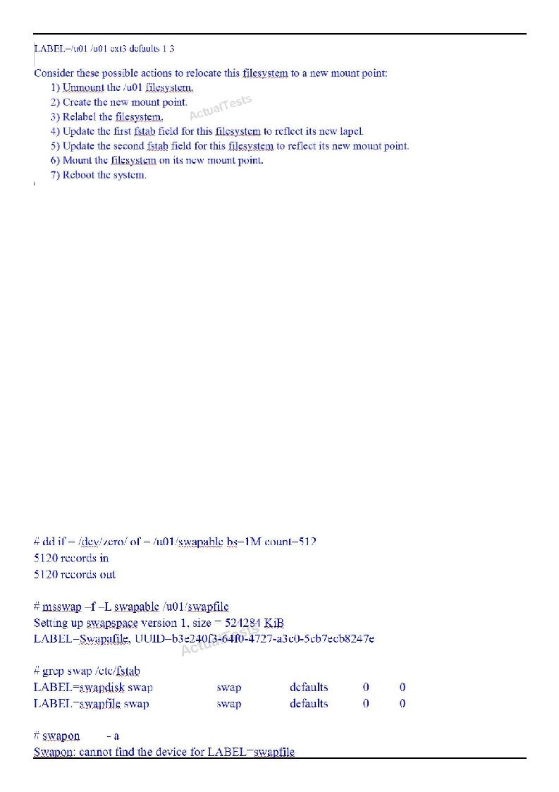
Oracle 1z0-100 Exam
Identify the actions you must perform to relocate this filesystem permanently to its new mount point?
A.1, 2, 3, 4, 5, 6 and 7
B.1, 2, 3, 4, 5 and 6
C.1, 2, 5 and 6
D.1, 2, 5, 6 and 7 ^
E.1, 2 and 6
Answer: C
Explanation:
QUESTION NO: 65
During the setup of additional swap space on an ext2 filessystem, you encounter an error as shown below:
"Pass Any Exam. Any Time." - www.TWPASS.com | 43
Oracle 1z0-100 Exam
Which action must you perform to add additional swap space?
A.Create a symbolic link /dev/swapfile that points to u01/swapfile.
B.Reinitialize /u01/swapfile by issuing mkswap -L swapfile /u01/swapfile. C. Re-create the swapfile on an ext3 or ext4 filesystem.
D.Change LABEL=swapfile to /u01/swapfile in the appropriate /etc/fstab entry. E.None, because adding filesystem based swap space is not supported.
Answer: D
Explanation:
QUESTION NO: 66
Examine the command and output shown:
bash-4.1# 1s
1s: error while loading shared libraries: libselinux.so.1: cannot open shared object file: No such file or directory
No files have been deleted from your system and you want to determine the cause of the error.
Which two commands or utilities can help the root user diagnose this problem?
A.ldd
B.dmesg
C.grep libselinux.so.1 /var/log/dmesg
D.strace
E.grep libselinux.so.1 /var/log/message
Answer: A,D
Explanation:
To diagnose the problem, use the following commands:
ldd /usr/bin/ls and
ldd /cat
strace -o /tmp/ls.strace -f su - root -c ls
Reference: http://www.experts-exchange.com/OS/Unix/Q_25150132.html
"Pass Any Exam. Any Time." - www.TWPASS.com | 44
Oracle 1z0-100 Exam
QUESTION NO: 67
Examine this sequence of commands and output:
[root@FARAWAY ~] # cat /etc/oracle-release Oracle Linux Server release 6.1
[root@FARAWAY ~]# rpm -qa oraclelinux* Oraclelinux-release-noted-6Server-5.x86_64Oraclelinux-release-6Server-1.0.2.x86_64
[root@FARAWAY ~] # rpm -qa rehat-release* [root@FARAWAY ~] #
[root@FARAWAY ~] # rpm -qf /etc/oracle-releaseOraclelinux-release-6Server-1.0.2.x86_64
[root@FARAWAY ~] rpm -qf /etc/redhat-releaseOraclelinux-release-6Server-1.0.2.x86_64
Which two can be determined from this output?
A.The system has Oracle Linux 6 installed and the Red Hat compatible kernel is running.
B.The system has Oracle Linux 6 installed and the Oracle Unbreakable Enterprise kernel Is running.
C.It is not possible to determine which kernel is running.
D.This system has been booted at least once, with the Red Hat-compatible kernel and once with the Unbreakable Enterprise kernel.
E.The oracle-release package contains both Oracle and Red Hat release metadata.
Answer: C,E
Explanation:
QUESTION NO: 68
"Pass Any Exam. Any Time." - www.TWPASS.com | 45
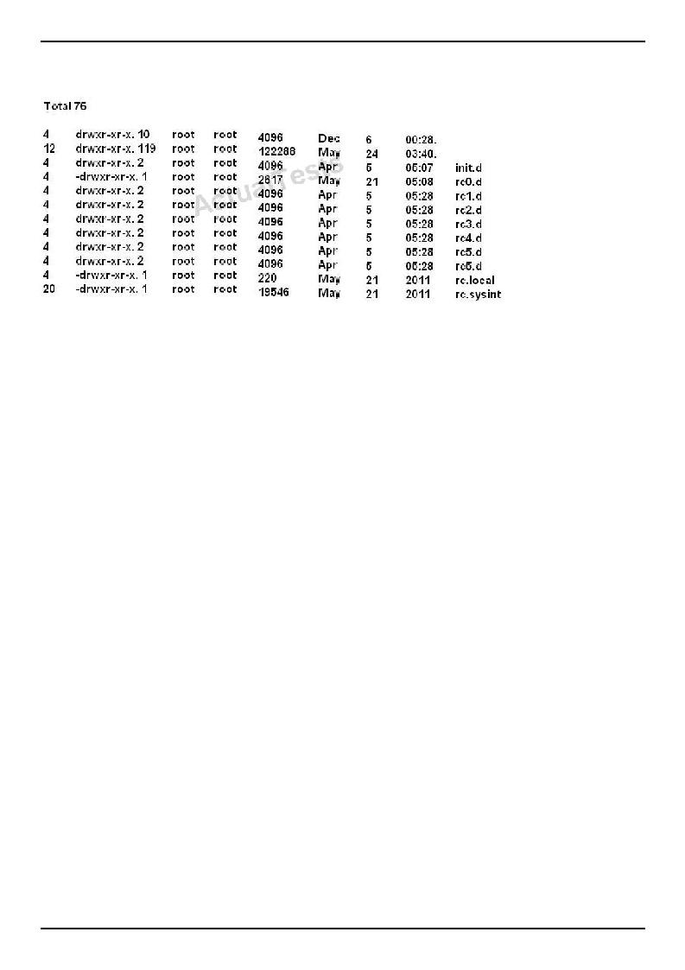
Oracle 1z0-100 Exam
Examine the contents of /etc/rc.d
Which two statements are true concerning the files contained in the run level-specific directories rc0.d through rc6.d?
A.The files starting with S or K are links to scripts in the /ete/init.d directory.
B.The files starting with S are always invoked by the /etc/rc.d/rc script even if the service managed by that script is already down.
C.The files starting with S or K are added by using the chkcor.fig command.
D.The files starting with K are always invoked by the /rc/rc,d/re script even if the service managed by that script is already up.
E.The files starting with S are invoked before those starting with K.
Answer: A,C
Explanation:
QUESTION NO: 69
As root, you enter a crontab command as shown;
[root@FAROUT cron.daily] # crontab -1 */2 * * * * vmstat
0 0 1 1-5 * iostat [root@FAROUT cron.daily] #
Which three statements are true concerning the two cron jobs listed?
"Pass Any Exam. Any Time." - www.TWPASS.com | 46
Oracle 1z0-100 Exam
A. The iostat command runs at midnight of every day except Sunday.
B.The vmstat command runs twice per hour.
C.The vmstat command runs every other hour.
D.The vmstat command runs every second minute. E. All cron job output is sent to the root user's mall. F. All cron job output is sent to /var/log/messages.
G.The iostat command runs at midnight on the first day of each of the first five months of the year.
Answer: D,E,G
Explanation:
QUESTION NO: 70
Which three statements are true configuration files and the behavior of module parameters specified in those files, in the /etc/modprobe.d directory?
A.The files may contain options to be passed to a module only when it is a dependency of a module being inserted.
B.The file may contain shell commands to be run instead of inserting a particular module in the kernel.
C.The files may contain options to be passed to a module, only when it is inserted using a modprobe command.
D.The files may contain alias names for modules.
E.The file may contain instructions to ignore certain modules.
F.The files may contain options to be passed to a module only when it is Inserted using an insmod command.
Answer: A,C,D
Explanation: modprobe.d - Configuration directory for modprobe
Because the modprobe command can add or remove more than one module, due to modules having dependencies, we need a method of specifying
what options are to be used with those modules (A). All files underneath the /etc/modprobe.d directory which end with the .conf extension specify those options as required. They can also be used to create convenient aliases (D): alternate names for a module, or they can override the normal modprobe behavior altogether for those with special requirements (such as inserting more than one module).
C: options modulename option...
This command allows you to add options to the module modulename (which might be an alias) every time it is inserted into the
kernel: whether directly (using modprobemodulename or because the
"Pass Any Exam. Any Time." - www.TWPASS.com | 47
Oracle 1z0-100 Exam module being inserted depends on this module.
QUESTION NO: 71
Which two statements are true regarding the use of the ssh-agent and ssh-add commands?
A.The ssh-agent is used to hold private keys.
B.The ssh-add command may ask for a passphrase each time the same key is required by the same user in the same shell.
C.The ssh-agent is used to hold only public keys.
D.The ssh-add command asks for the passphrase only the first time a key is required by the same user in the same shell.
E.The ssh-add command retries the most recently saved passphrase if multiple key files are used.
Answer: A,D
Explanation: A (not C): If you want to omit passphrase and password entry when you are using Solaris Secure Shell, you can use the agent daemon. Use the ssh-agent command at the beginning of the session. Then, store your private keys with the agent by using the ssh-add command.
D: Add your private key to the agent daemon.
The ssh-add command adds your private key to the agent daemon so that subsequent Secure Shell activity does not prompt you for the passphrase.
myLocalHost% ssh-add
Enter passphrase for /home/johndoe/.ssh/id_rsa:
Identity added: /home/johndoe/.ssh/id_rsa(/home/johndoe/.ssh/id_rsa) myLocalHost%
QUESTION NO: 72
Users complain that system performance is unacceptable when using a specific application service running on a multiprocessor service.
You have established from the storage team that disk response times have not increased, so you can discount there being an I/O problem.
"Pass Any Exam. Any Time." - www.TWPASS.com | 48
Oracle 1z0-100 Exam
You run vmstat to look at CPU activity and notice high average disk times on the multiprocessor system and an average run queue of zero.
You require more detail about each CPU from which the vmstat figures are derived, to investigate if the load is distributed evenly across all CPUs.
Which three commands provide more detailed information about CPU load distribution?
A.iostat -x
B.top
C.mpstat D. vmstat
E.sar
Answer: C,D,E
Explanation: C: A useful command to get CPU related stats is mpstat. Here is an example output:
# mpstat -P ALL 5 2
Linux 2.6.9-67.ELsmp (oraclerac1) 12/20/2008
10:42:38 PM CPU %user %nice %system %iowait %irq %soft %idle intr/s 10:42:43 PM all 6.89 0.00 44.76 0.10 0.10 0.10 48.05 1121.60
10:42:43 PM 0 9.20 0.00 49.00 0.00 0.00 0.20 41.60 413.00 10:42:43 PM 1 4.60 0.00 40.60 0.00 0.20 0.20 54.60 708.40 etc.
D: When called, the grand-daddy of all memory and process related displays, vmstat, continuously runs and posts its information. It takes two arguments:
# vmstat <interval> <count>
<interval> is the interval in seconds between two runs. <count> is the number of repetitions vmstat makes. Here is a sample when we want vmstat to run every five seconds and stop after the tenth run. Every line in the output comes after five seconds and shows the stats at that time.
# vmstat 5 10
procs ----------- | memory---------- | ---swap-- | -----io---- | --system-- ---- | cpu----
r b swpd free buff cache si so bi bo in cs us sy id wa
0 0 1087032 132500 15260 622488 89 19 9 3 0 0 4 10 82 5
0 0 1087032 132500 15284 622464 0 0 230 151 1095 858 1 0 98 1 0 0 1087032 132484 15300 622448 0 0 317 79 1088 905 1 0 98 0 … shows up to 10 times.
The output shows a lot about the system resources.
"Pass Any Exam. Any Time." - www.TWPASS.com | 49
Oracle 1z0-100 Exam
E: sar stands for System Activity Recorder, which records the metrics of the key components of the Linux system—CPU, Memory, Disks, Network, etc.—in a special place: the directory /var/log/sa.
The simplest way to use sar is to use it without any arguments or options. Here is an example:
# sar
Linux 2.6.9-55.0.9.ELlargesmp (prolin3) 12/27/2008
12:00:01 AM CPU %user %nice %system %iowait %idle 12:10:01 AM all 14.99 0.00 1.27 2.85 80.89
12:20:01 AM all 14.97 0.00 1.20 2.70 81.13 12:30:01 AM all 15.80 0.00 1.39 3.00 79.81 12:40:01 AM all 10.26 0.00 1.25 3.55 84.93
Incorrect:
Not A: iostat is for I/O
QUESTION NO: 73
Which three statements are true concerning filesystems supported by Oracle Linux?
A. An ext3 filesystem can be mounted as an ext2 filesystem. B.An ext4 filesystem can be mounted as an ext3 filesystem.
C. The ext3 and ext4 filesystems both support multiple journaling modes. D.The btrfs filesystem includes a volume manager.
E. The btrfs filesystem cannot be used for the root filesystem. F.The ext4 filesystem is a copy-on-write filesystem.
Answer: A,C,D
Explanation: A: ext2 file systems are upgradeable to ext3 without reformatting.
C: The ext3 file system includes journaling capabilities to improve reliability and availability. In addition to the features of ext3, the ext4 file system supports extents (contiguous physical blocks), pre-allocation, delayed allocation, faster file system checking, more robust journaling, and other enhancements.
"Pass Any Exam. Any Time." - www.TWPASS.com | 50
Oracle 1z0-100 Exam
QUESTION NO: 74
The SSHD service is controlled by the script in /etc/init.d/sshd, part of which is shown here:
[root@FAROUT ~] cat /etc/init.d/sshd
#!/bin/bash
#sshdStart up the OpenSSH server daemon
#chkconfig: 23455525
#description: SSH is a protocol for secure remite shell access. \
#This service starts up the Open SSH server daemon.
#
You issue chkconfig commands to change the sshd service:
[root@FAROUT ~] # chkconfig sshd off [root@FAROUT ~] # chkconfig sshd reset
What is the result of the two commands issued?
A.The sshd service configuration is restored to the settings that existed before setting it off.
B.The sshd service configuration is restored to start In run levels 2, 3, 4 and 5. C. The sshd service configuration is restored to start in run levels 2 and 5 only.
D.The sshd service configuration is restored to those that existed after the operating system was first installed.
Answer: D
Explanation:
QUESTION NO: 75
For which three types of installs does the Oracle database Pre-install rpm help by installing required software packages and setting system parameters?
"Pass Any Exam. Any Time." - www.TWPASS.com | 51
Oracle 1z0-100 Exam
A.Oracle Database 11g Enterprise Edition single instance
B.Oracle WebLogic
C.Oracle Database Enterprise Edition Real Application Cluster
D.Oracle Enterprise Manager Cloud Control
E.Oracle Database 11g Standard Edition single instance
Answer: A,B,E
Explanation:
QUESTION NO: 76
Which three statements are true concerning the IPTABLES Oracle Linux firewall?
A.The default rule table is filter.
B.iptables has two main components: the kernel component netfilter and the command-line utility ipchains.
C.Input, output, and forward are the rule tables associated with filter.
D.PREROUTING, OUTPUT, and POSTROUTING are the chains associated with nat. E.
The main rule chains are filter, nat, and mangle. F. The main rule tables are filter, nat, and mangle.
Answer: A,D,F
Explanation: A: You need to specify the table and the chain for each firewall rule you create. There is an exception: Most rules are related to filtering, so iptables assumes that any chain that's defined without an associated table will be a part of the filter table. The filter table is therefore the default.
D: Nat Network Address Translation PREROUTING
Address translation occurs before routing. Facilitates the transformation of the destination IP address to be compatible with the firewall's routing table. Used with NAT of the destination IP address, also known as destination NAT or DNAT.
POSTROUTING
Address translation occurs after routing. This implies that there was no need to modify the destination IP address of the packet as in pre-routing. Used with NAT of the source IP address using either one-to-one or many-to-one NAT. This is known as source NAT, or SNAT. OUTPUT
Network address translation for packets generated by the firewall. (Rarely used in SOHO environments)
F: There are three tables in total. The first is the mangle table which is responsible for the
"Pass Any Exam. Any Time." - www.TWPASS.com | 52
Oracle 1z0-100 Exam alteration of quality of service bits in the TCP header.
The second table is the filter queue which is responsible for packet filtering. It has three built-in chains in which you can place your firewall policy rules.
The third table is the nat queue which is responsible for network address translation.
QUESTION NO: 77
Which two statements are true about signal handling in Oracle Linux?
A.The pkill command kills a process by name.
B.A process killed with the default signal always terminates gracefully if it: does not block the kill request.
C.The kill command sends a sigkill (signal 9) by default to the process being killed. D.
The kill command may send a termination signal to more than one process at a time. E. All signals may be blocked by a process.
Answer: B,D
Explanation: D: The kill command is used to send a termination signal to the specified process or group.
Incorrect:
Not A: The following example shows the xscreensaver process (2609) which is to be terminated.
$ pgrep xscreen 2609
$ kill 2609
Though we use pgrep to find the PID of this process here we could have also used a PID from the output of top or ps.
Not C: The kill command is used to send a termination signal to the specified process or group. The default termination signal is a SIGTERM (15) signal.
Not E: When there a stubborn process trapping the kill command and refusing to terminate, the -9 (SIGKILL) signal should be used to kill the process. The -9 signal cannot be trapped by a process and ignored.
QUESTION NO: 78
Bash is invoked as an interactive login shell.
"Pass Any Exam. Any Time." - www.TWPASS.com | 53
Oracle 1z0-100 Exam
What is the order in which the bash configuration files are read, assuming that all the files exist in their correct location and are readable?
A./etc/profile, ~/ .profile
B./etc/profile, ~/ .bash_profile
C./etc/profile, ~/ .bash_profile, ~/ .bash_login, ~/ .profile D./etc/profile, ~/ .bash_profile, ~/ .profile, ~/ .bash_login
Answer: C
Explanation: When Bash is invoked as an interactive login shell, or as a non-interactive shell with the --login option, it first reads and executes commands from the file /etc/profile, if that file exists. After reading that file, it looks for ~/.bash_profile, ~/.bash_login, and ~/.profile, in that order, and reads and executes commands from the first one that exists and is readable. The --noprofile option may be used when the shell is started to inhibit this behavior.
When a login shell exits, Bash reads and executes commands from the file ~/.bash_logout, if it exists.
QUESTION NO: 79
Which type of nameserver is provided by the default bind configuration files on Oracle Linux?
A.A primary name server
B.A secondary name server
C.Recursive caching-only nameserver
D.An authoritative name server
E.Slave name server
Answer: A
Explanation:
QUESTION NO: 80
Which three statements are true concerning the use of the grub menu in Oracle Linux?
A.All changes made using the grub editor at boot time are saved by default to /boot/grub/grub, conf.
B.Additional parameters may be passed to the selected kernel. C.
The initrd directive may not be changed.
D. Existing kernel parameters may be changed.
"Pass Any Exam. Any Time." - www.TWPASS.com | 54
Oracle 1z0-100 Exam
E. Some of the GRUB command-line functions may be password protected.
Answer: A,B,D
Explanation: A: GRUB requires only the file name and drive partitions to load a kernel. You can configure this information by editing the /boot/grub/grub.conf file, by using the GRUB menu, or by entering it on the command line.
Incorrect:
not C: If you have set a GRUB password, you must press P and enter the valid password to be able to edit the titles or change kernel boot parameters. To edit any of the root, kernel, or initrd directives, press E. To edit the kernel directive only, press A. To use the GRUB command line, press C.
If you press E, select the root, kernel, or initrd directive, and press E to edit it.
Not E: Grub can be password protected, but not individual functions.
QUESTION NO: 81
Consider the output shown:
#rpm -i sendmail-cf-8.14.4-8.e16.noarch.rpm
Error: Failed dependencies:
Sendmail = 7.14.4-8.e16 is needed by sendmail-cf-8.e16.noarch
#rpm -i sendmail-8.14.4-8.e16.x86_64.rpm
#rpm -i sendmail-cf-8.14.4-8.e16.noarch.rpm
#rpm -q sendmail sendmail-cf
Sendmail-8.14.4-8.e16.x86_64
Sendmail-cf-8.e16_64
Sendmail-cf-8.14.4-8.e16.noarch
# rpm -e sendmail
Which statement is true about the execution of the rpm -e sendmail command?
A. It erases the sendmail package without errors.
"Pass Any Exam. Any Time." - www.TWPASS.com | 55
Oracle 1z0-100 Exam
B.It fails with an error because the package version is not supplied on the command line.
C.It fails with an error because the sendmail-cf package depends on the sendmail package.
D.It erases the sendmail package and raises an error because the sendmail package depends on the sendmail package.
E.It erases both the sendmail and sendmail-cf packages because the sendmail-cf package depends on the sendmail package.
Answer: C
Explanation:
QUESTION NO: 82
Which three statements are true about the User Private Group scheme in Oracle Linux?
A.If a user jules is added with the useradd jules command, a group called jules_grp is also created
B.The umask for the jules user is 002 in /etc/bashrc
C.Users belonging to a group to which user jules also belongs, are automatically able to write to the private group belonging to the jules user.
D.If a user jules is added with the user add jules command, a group called jules is also added. but no other user may be a member of that group.
E.A directory owned by a group to which several users belong, and which has the setgid fa turned on, has shared write access to all members of the group.
F.The User private Group scheme is enabled by default in Oracle Linux.
Answer: D,E,F
Explanation: DF (not A): By default, Oracle Linux implements the user private group (UPG) scheme where adding a user account also creates a corresponding UPG with the same name as the user, and of which the user is the only member.
E: When setgid permission is applied to a directory, files that were created in this directory belong to the group to which the directory belongs, not the group to which the creating process belongs. Any user who has write and execute permissions in the directory can create a file there. However, the file belongs to the group that owns the directory, not to the user's group ownership.
QUESTION NO: 83
Which two actions are the required steps to prevent: non-root ssh access to the system?
A. Ensuring that /etc/pam.d/sshd includes:
"Pass Any Exam. Any Time." - www.TWPASS.com | 56
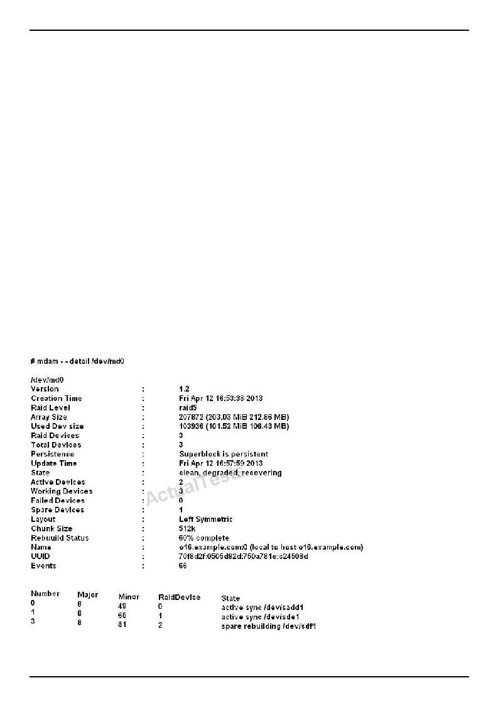
Oracle 1z0-100 Exam
account sufficient pam_nologin.so
B.Create the /etc/nologin/login.deny file containing a single line +all
C.Creating the /etc/nologin.allow file containing a single line root
D.Creating the /etc/nologin file
E.Ensuring that /etc/pam.d/sshd includes:
account requiredpam_nologin.so
Answer: D,E
Explanation:
D: If the file /etc/nologin exists, only root is allowed to log in; other users are turned away with an error message.
Note:
* In some cases, the security policy may dictate additional mechanisms, such as TCP wrappers, Pluggable Authentication Modules (PAM), or the implementation of Security-Enhanced Linux (SELinux).
QUESTION NO: 84
Examine this MDAM output:
"Pass Any Exam. Any Time." - www.TWPASS.com | 57
Oracle 1z0-100 Exam
Which two aspects can be determined from this output?
A. A RAID device failed and has been replaced with the hot spare. B. A new RAID device was just added to replace a failed one.
C. Read and write performance is currently not optimal on this RAID set. D.Only write performance is currently not optimal on this raid set. E. An extra device was added to this RAID set to increase its size.
Answer: A,E
Explanation:
QUESTION NO: 85
Which three statements are true about the Oracle Linux Logical Volume Manager (LVM)?
A. LVM supports simple, striped, mirrored, and RAID-5 Logical Volumes (LVs). B.A Physical Volume (PV) can be created on a disk or a disk partition. C. A Physical Volume (PV) can only be created on a disk partition. D. A Physical Volume (PV) can be resized.
E. A Volume Group (VB) can be split into multiple Volume Groups. F.An LVM snapshot is read-only.
Answer: B,D,E
Explanation:
QUESTION NO: 86
You want to convert an rpm packages file into a standard format as part of a shell script and then manipulate the contents.
Which archive format is used by rpm?
A.cpio
B.tar
C.bzip2
D.gzip
E.zip
Answer: A
Explanation:
"Pass Any Exam. Any Time." - www.TWPASS.com | 58
Oracle 1z0-100 Exam
QUESTION NO: 87
Which four statements correctly describe the contents of the sysfs filesystem?
A.It contains kernel parameter files.
B.It contains metadata on all block devices. C. It contains metadata on firmware.
D.It contains metadata on all loaded modules in the kernel. E. It contains metadata on device classes. F. It contains metadata on system uptime.
Answer: B,C,D,E
Reference: https://www.kernel.org/pub/linux/kernel/people/mochel/doc/papers/ols- 2005/mochel.pdf
QUESTION NO: 88
Which three statements are true about the mount command?
A.It supports labels.
B.By default, it can be used by an ordinary user to mount a local file system.
C.It lists all the currently mounted filesystems, if executed without any arguments
D.It lists only the filesystems listed in /etc/fstab if executed without any arguments. E.Only root can mount filesystems that are not listed in listed in /etc/fstab.
Answer: A,C,E
Reference: https://access.redhat.com/site/documentation/en- US/Red_Hat_Enterprise_Linux/5/html/Deployment_Guide/chap-Using_the_mount_Command.html
QUESTION NO: 89
Examine these configuration files:
# cat /etc/auto.master
"Pass Any Exam. Any Time." - www.TWPASS.com | 59
Oracle 1z0-100 Exam
/net-hosts
/- auto.direct ro
# cat /etc/auto.direct
/nfs1 o16:/export/share1
/nfs2 -sync o16:/export/share2 /nfs o16:/export/share3
Which mount options will automounter use to mount the filesystems listed in /etc/auto.direct?
A.All three filesystems are mounted read-only, async.
B./nfs1 and /nfs3 are mounted read-only, async whereas /nfs2 mounted read-write, sync. C./nfs1 and /nfs3 are mounted read-only, async whereas /nfs2 mounted read-only, sync. D. All three filesystems are mounted read-write, sync.
Answer: C
Explanation:
QUESTION NO: 90
Examine the UserDir directives in this extract from /etc/httpd/conf/httpd.conf:
<IfModule mod_userdir.c> UserDirenabled user1 UserDirdisabled user1 UserDirpublic_html </IfModule>
The web server URL is http://host01.
A website server URL is http://host01.
A user attempts to access user1's webpages using this URL:
"Pass Any Exam. Any Time." - www.TWPASS.com | 60
Oracle 1z0-100 Exam
httpd:/host01/~user1
Which statement describes the outcome?
A.The occurrence user1 in the list of disabled users causes an access denied error to the website contained in user1'1 public_html subdirecroty, overriding the enabled directive.
B.The occurrence of user1 in the list of enabled users allows access to the website contained in user1's public_html subdirectory, overriding the disabled directive.
C.The configuration produces an error upon web server startup, because the enabled and disabled directive conflict.
D.Access is guaranteed because the UserDir public_html directive applies default access to all local users on the system, overriding the enabled of disabled directive.
Answer: B
Explanation:
QUESTION NO: 91
Which three Statements describe the capabilities and functions of the chkconfig command in Oracle Linux?
A.It can be used to change the state of a service.
B.It can be used to specify the run levels for which a service is to be activated.
C.It can be used to list all services and their run levels-
D.It can be used to check the status of a service to see if it is running. E.
It can be used to add a service.
Answer: B,C,E
Explanation:
QUESTION NO: 92
Which three statements are true concerning the use of open SSH utilities?
A. SCP always requires a passphrase to be used. B.
SCP permits copies between two remote hosts.
C.SFTP permits transfers between two remote hosts.
D.SSH may be used to execute a single command on a remote host instead of executing the login shell on the remote host.
E.SFTP may be used to execute a command on the remote server.
"Pass Any Exam. Any Time." - www.TWPASS.com | 61
Oracle 1z0-100 Exam
Answer: B,D,E
Explanation:
QUESTION NO: 93
The default locations and paths used by logwatch are:
/etc/logwatch/conf
/user/share/logwatch/default.conf
/user/share/logwatch/dist.conf
Which three statements are true logwatch installation and configuration?
A.After installing logwatch, no configuration is required to produce reports from system logs.
B.After installing logwatch, the /usr/share/logwatch/dist.conf directory will not exist because it is optional.
C.After installing logwatch, you must create /etc/logwatch/conf to produce reports from system logs.
D.After installing logwatch, all the default directories continue to exist.
E.To produce a report from the previous day's logs, the - - range yesterday parameter must be specified.
F.Running /usr/sbin/logwatch produces a report of the previous day's log files.
Answer: A,E,F
Explanation:
QUESTION NO: 94
Which three tasks should be performed to configure a host to act as an SSH server?
A. The openssh-server package must be installed. B.
The sshd service must be started.
C.The openssh package must be installed.
D.The openssh-client package must not be installed. E.The ssh-agent must be running.
Answer: A,B,C
Reference: https://access.redhat.com/site/documentation/en-
"Pass Any Exam. Any Time." - www.TWPASS.com | 62
Oracle 1z0-100 Exam
US/Red_Hat_Enterprise_Linux/6/html/Deployment_Guide/s2-ssh-configuration-sshd.html
QUESTION NO: 95
Which three methods might be used to change kernel parameters, thereby modifying the values for running system?
A.Using the echo command to write values to specific files in the /sys directory
B.Issuing the sysct1 -w command to write values to specific files in the /proc/sys directory
C.Issuing the sysct1 -w command to write values to specific files in the /sys directory
D.Adding to or modifying parameters in /etc/sysct1.conf and issuing the sysct1 -p command
E.Using the echo command to write values to specific files in the /proc/sys directory
Answer: B,D,E
Explanation:
QUESTION NO: 96
Examine some of the contents of the /boot/grub/grub.com file from an Oracle Linux system:
Default=0
Timeout=5
Splashimage=(hd0, 0)/grub/splash.xpm.gz
Hiddenmenu
Title Oracle Linux Server (2.6.39-100.0.12.16uek.x86_64)
Root (hd0, 0)
Kernet /vmlinuz-2.6.39-100.0.12.e16uek.x86_64 ro root=UUIP=a4b6049b-9aa1-44b4-87cf- aebb17alcdf9 rd_NO_LUKS re_NO_LVM rd_NO_DM LANG=en_US.UTF-8
SYSFONT=1atarcycreheb-sun16 KEYBOARDTYPE=PC KEYTABLE=us rhgb quiet numa=off
Initrd /initramfs-2.6.39-100.0.12.e16uek.x86_64.img
Title Oracle Linux Server (2.6.32-131.0.15.e16.x86_64)
Root (hd0, 0)
"Pass Any Exam. Any Time." - www.TWPASS.com | 63
Oracle 1z0-100 Exam
Kernel /vmlinuz-2.6.32-131.0.15.e16.x86_64 ro root=UUIS=a4b6049b-9aa1-44b4-87cf- aebb17a1cdf9 rd_NO_LUKS rd_NO_LVM rd_NO_LVM re_NO_MD rd_NO_DM
LANG=en_UD.UTF-8 SYSFONT=latarcyheb-sun16 KEYBOARDTYPE=PC KEYTABLE=us
Crashkernel=auto rhgp quiet numa = off
Initrd /initramfs-2.6.32-131.0.15.e16.x86_64.img
Which three statements are true about the behavior and configuration of GRUB on this system?
A.(hd0, 0) represents the first partition on device /dev/hd0.
B.The hiddenmenu directive hides the GRUB menu only for 5 seconds after which it becomes visible again.
C.The root directive specifies an initial root filesystem, allowing access to block device modules to mount the real root filesystem on disk.
D.(hd0, 0) represents the first partition on the first drive detected by the BIOS.
E.The initrd directive specifies the initamfs, an initial root filesystem in RAM, allowing access to block device modules to mount the real root filesystem.
F.Each kernel must have an initramfs that matches the version of the kernel.
G.Because there is an Unbreakable Enterprise Kernel installed, it must be the default kernel listed as shown by the default=0 directive.
Answer: A,C,E
Explanation:
QUESTION NO: 97
Identify three features/functions enabled by using asmlib?
A.Application-to-disk data integrity checking
B.Device naming persistence
C.Replaces udev for all files used by any application
D.Device ownership persistence
E.Multipathing driver for luns used for asmdisks F.locking facility for using luns in an ASM cluster
Answer: D,E,F
Explanation:
QUESTION NO: 98
"Pass Any Exam. Any Time." - www.TWPASS.com | 64
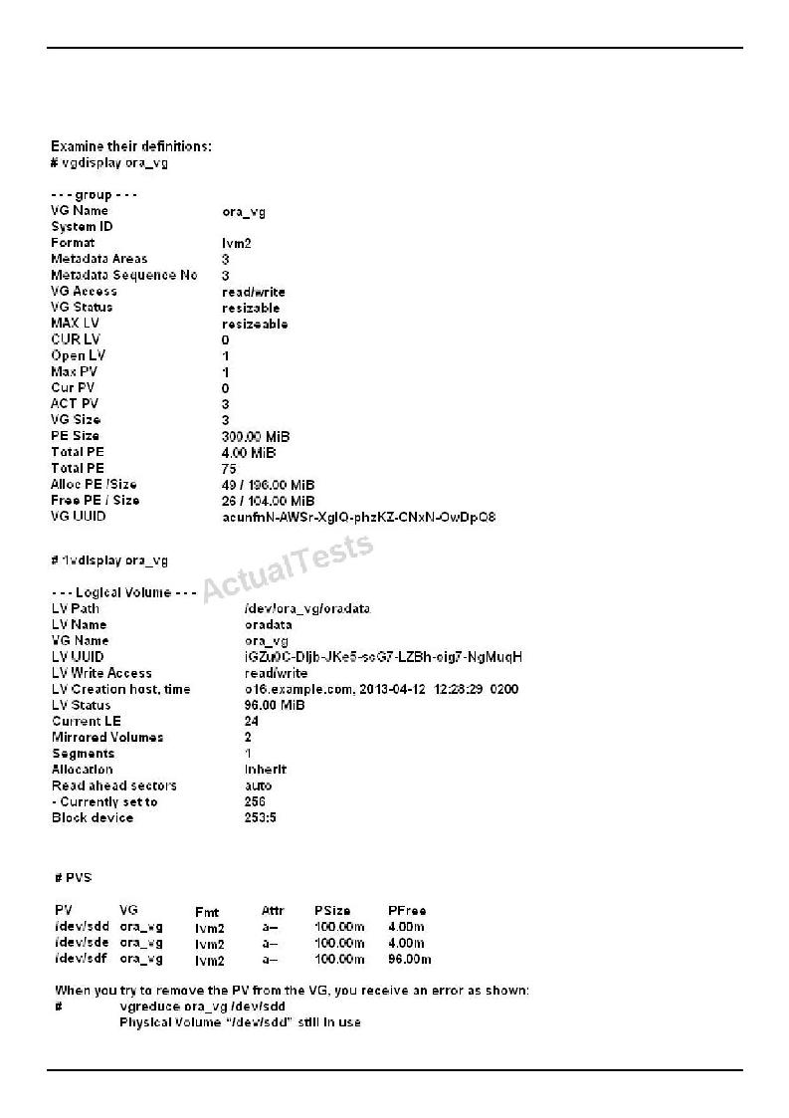
Oracle 1z0-100 Exam
You must remove a Physical Volume (PV) from a Volume Group (VG) containing one Logical Volume (LV) without compromising data availability.
"Pass Any Exam. Any Time." - www.TWPASS.com | 65
Oracle 1z0-100 Exam
What must you do before using the vgreduce command, to remove the PV?
A.Move allocated physical Extents (PE) from /dev/sdd to other physical volumes using the pvmove command.
B.Remove the /dev/sdd PV using the pvremove command.
C.Resize the /dev/sdd PV to zero using the pvresize command.
D.Move allocated physical Extents (PE) from /dev/sdd to other physical volumes by using the 1vvonvert - - replace command.
Answer: A
Explanation: https://access.redhat.com/documentation/en- US/Red_Hat_Enterprise_Linux/5/html/Logical_Volume_Manager_Administration/VG_remove_PV. html
QUESTION NO: 99
Examine some rules from the /etc/rsyslog.conf file:
*.info;mail.debug;authpriv.none;cron.none/var/log/messages uucp, news.notice/var/log/spooler
Which statement is true about the listed rules?
A.Only messages with a priority of info from all facilities are sent to /var/log/messages.
B.Only messages with a priority of notice from the news facility are sent to /var/log/spooler.
C.Messages with a priority of debug or higher from the mail facility are sent to /var/log/message
D.Only messages with a priority of debug from the mail facility are sent to /var/log/messages.
Answer: C
Explanation:
QUESTION NO: 100
Examine this output captured on an NFS server:
# mount | grep export
/dev/sdc1 on /export type ext3 (rw)
"Pass Any Exam. Any Time." - www.TWPASS.com | 66
Oracle 1z0-100 Exam /dev/sdc2 on /export/share2 type ext3 (rw)
# cat /etc/exports /export (*ro)
You mounted the /export filesystem on an NFS client using the command:
# mount NFS_SERVER:/export/mnt
What is the result of listing the files in /mnt/share2 on the NFS client?
A.It lists any files stored in the share2 directory in the /dev/sdc1 partition of the NFS server.
B.It lists any files stored in the root directory in the /dev/sdc2 partition of the NFS server. C. It results in a permission denied error. D. It results in a stale NFS handle error. E. It produces no output.
Answer: B
Explanation:
QUESTION NO: 101
A web server on HOST01 is listening on port 80.
Examine the IPTABLES rule shown: [root@host01 ~] # iptables -L INPUT
Chain INPUT (policy ACCEPT)
targetportoptsourcedestination
ACCEPTtcp- - anywhereanywheretcp dpt:http
Another rule is then added:
[root@host01 ~] # iptables -A INPUT -P tcp - - dport 80 -j REJECT
What is the effect of this command on subsequent attempts to access the web server on HOST01
"Pass Any Exam. Any Time." - www.TWPASS.com | 67
Oracle 1z0-100 Exam
using port 80?
A.New connection attempts timeout.
B.New connection attempts are refused and the client informed of the refusal. C.
New connection attempts always succeed.
D. New connection attempts succeed until a reload of the firewall rules.
Answer: A
Explanation:
QUESTION NO: 102
Which three actions may be performed using the date command in Oracle Linux?
A.Setting the hardware clock from the current system time
B.Setting the system time from the hardware clock
C.Displaying the current time in an administrator-specified format
D.Displaying the time and date in the future
E.Displaying the time and date in the past
F.Synchronizing the system time from an ntp server
Answer: C,D,E
Explanation:
QUESTION NO: 103
Match the following symbolic notations of the file permissions with their numeric values:
- - - - S - - | - - - - a) 5000 - - - -
- - - S - - - | b) 4100 - - - - - - - - - -
-tc) 7101 - - - - S - - - - - Td) 1001 - - - - S - - S - - te) 7040
-S - - S r - - - Tf) 2010
A. 1-d, 2-f, 3-b, 4-e, 5-c, 6-a B. 1-b,2-f, 3-d, 4-a, 5-c, 6-e C. 1-f, 2-a,3-c, 4-b, 5-e, 6-d D. 1-b, 2-d, 3-f,4-a, 5- e, 6-c
Answer: B
"Pass Any Exam. Any Time." - www.TWPASS.com | 68
Oracle 1z0-100 Exam
Explanation:
QUESTION NO: 104
The dailyrun.sh shell script run by the user hr on a daily basis suddenly returns an error.
You investigate this by running the commands manually as user hr and discovered that this line of shell cod is responsible:
1s -als > /home/prodrun/files.1st
Bash: files.1st:cannot overwrite existing file
What is the cause of this error?
A. The hr user has no write permissions on the /home/prodrun/files.1st file. B.The hr user has no write permissions on the /home/prodrun directory. C. The dailyrun.sh shell script has the setuid bit turned off. D. The hr user environment has set on the noclobber option.
Answer: D
Explanation:
QUESTION NO: 105
Examine the output shown:
[root@FAROUT fs] # rpm -qa | grep preinstall
Oracle-rdbms-server-11gR2-preinstall-1.0-6.e16.x86_64
[root@FAROUT fs] # rpm -q1oracle-rdbms-server-11gR2-preinstall-1.0-6.e16.x86_64 /etc/rc.d/init.d/oracle-rdbms-server-11gR2-preinstall-firstboot /etc/sysconfig/Oracle-rdbms-server-11gR2-preinstall-verify
/etc/sysconfig/oracle-rdbms-server-11gR2-preinstall/Oracle-rdbms-server-11gR2-preinstall.param
/usr/bin/oracle-rdbms-server-11gR2-preinstall-verify
"Pass Any Exam. Any Time." - www.TWPASS.com | 69
Oracle 1z0-100 Exam
Which three statements are true about oracle-rdbms-server-11gR2-preinstall-1.0-6.e16.x86_64 rpm?
A.It is a new name for oracle-validated package from Oracle Linux 5 that sets parameters to the same values.
B.It creates the oracle user if not already created, which owns the Grid Infrastructure software should that get installed.
C.It creates the grid user if not already created which owns the grid infrastructure software should that get installed.
D.It modifies kernel parameters in /etc/sysctl.conf.
E.It runs at the first boot after installing the packages to set a parameter indicating that is has run once.
F.It modifies parameters in the /etc/sysconfig/network-scripts directly. G. It
creates the osoper group, if not already created.
Answer: A,B,D
Explanation:
QUESTION NO: 106
You installed the sendmail-cf package using the yum command as shown:
# yum -Y install sendmail-cf Loaded plugins: security Setting up Install Process Resolving Dependencies
--> Running Transaction Check
-- - > Package sendmail-cf.noarch 0:8.14.4-8.e16 will be installed
-- > Processing Dependency: sendmail = 7.14.4-8.e16 for package: sendmail-cf-8.14.4- 8.e16.noarch
-- > Running transaction check
-- > Package sendmail.x86_64 0:8.14.4-8.e16 will be installed
-- > Finished Dependency Resolution
Dependency Resolved
"Pass Any Exam. Any Time." - www.TWPASS.com | 70
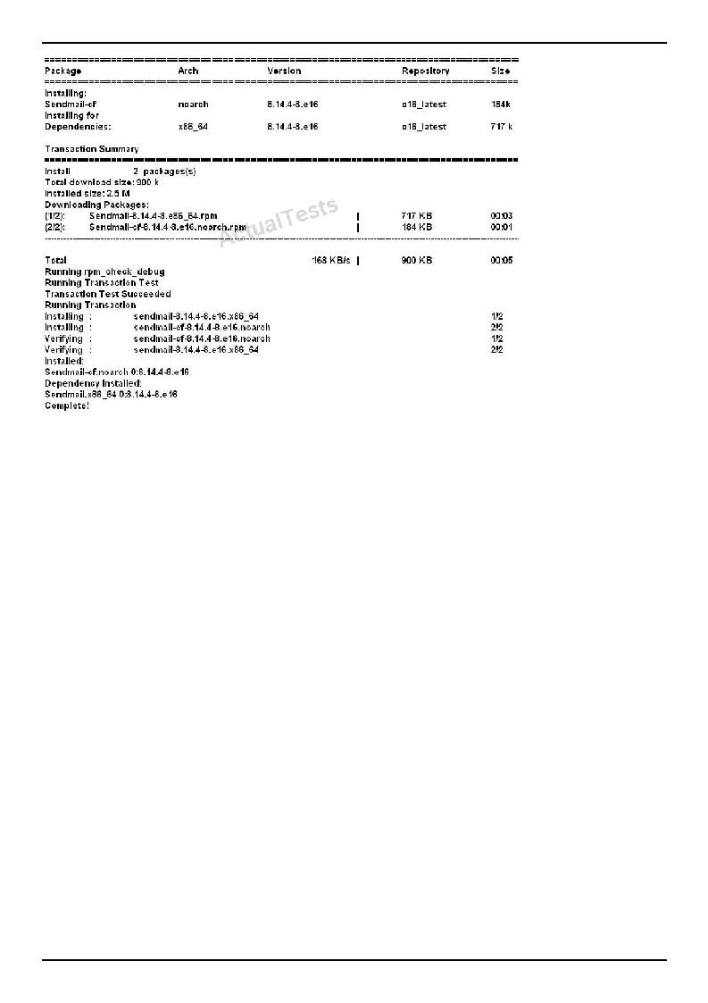
Oracle 1z0-100 Exam
What is the outcome of the YUM command?
# yun -y remove sendmail
A.It fails with an error because the sendmail-cf package depends on the package being removed.
B.It succeeds and removes both the sendmail and sendmail-cf packages. C. It succeeds and only removes the sendmail package.
D.It removes the sendmail packages and raises a warning about the sendmail-cf package, which depends on the package being removed.
E.It removes the sendmail package and prompts you for the option to remove the sendmail-cf package.
Answer: B
Explanation:
QUESTION NO: 107
The user smith, whose primary group is smith, wants to create a file in his home directory, which belongs to the group apps.
Which two statements are correct?
"Pass Any Exam. Any Time." - www.TWPASS.com | 71
Oracle 1z0-100 Exam
A.SGID should be set on smith's home directory to let smith create files that belong to a group that is not his primary group.
B.The user smith can create a file that belongs to the apps group, only If his private group is the apps group as per /etc/group.
C.The user smith can use the newgrp command to change the primary group to apps, only if smith is listed in /etc/group as a member of the apps group.
D.The user smith can use the newgrp command to change the primary group to apps, but a password is required if smith is not listed in /etc/group as a member of the apps group.
Answer: C,D
Explanation:
QUESTION NO: 108
Which three are valid directories for cron jobs to be run at known intervals?
A./etc/cron.hourly
B./etc/cron.daily
C./etc/cron.minutely D./etc/cron.monthly
E./etc/cron.yearly
F./etc/cron.annually
Answer: A,B,D
Explanation: An alternative to editing the crontab is to place executable scripts into one of the following directories. The script will be run at the appropriate interval.
/etc/cron.hourly
/etc/cron.daily
/etc/cron.weekly
/etc/cron.monthly
This is actually using anacron, rather than cron, but it achieves a similar goal. Reference: http://www.oracle-base.com/articles/linux/cron-on-linux.php

